UNITED STATES
SECURITIES AND EXCHANGE COMMISSION
Washington, D.C. 20549
___________________________________
FORM 8-K
___________________________________
CURRENT REPORT
Pursuant to Section 13 or 15(d)
of the Securities Exchange Act of 1934

Date of Report (date of earliest event reported): September 30, 2026
___________________________________
Arhaus, Inc.
(Exact name of registrant as specified in its charter)
___________________________________

Delaware  (State or other jurisdiction of  incorporation or organization) |  |  | 001-41009  (Commission File Number) |  |  | 87-1729256  (I.R.S. Employer Identification Number)
51 E. Hines Hill Road, Boston Heights, Ohio
(Address of Principal Executive Offices)
44236
(Zip Code)
(440) 439-7700
(Registrant's telephone number, including area code)

Check the appropriate box below if the Form 8-K filing is intended to simultaneously satisfy the filing obligation of the registrant under any of the following provisions:

☐ |  |  | Written communications pursuant to Rule 425 under the Securities Act (17 CFR 230.425)
☐ |  |  | Soliciting material pursuant to Rule 14a-12 under the Exchange Act (17 CFR 240.14a-12)
☐ |  |  | Pre-commencement communications pursuant to Rule 14d-2(b) under the Exchange Act (17 CFR 240.14d-2(b))
☐ |  |  | Pre-commencement communications pursuant to Rule 13e-4(c) under the Exchange Act (17 CFR 240.13e-4(c))
Securities registered pursuant to Section 12(b) of the Act:
Title of each class |  |  | Trading Symbol |  |  | Name of each exchange on which registered
Class A common stock, $0.001 par value per share |  |  | ARHS |  |  | The Nasdaq Global Select Market
Indicate by check mark whether the registrant is an emerging growth company as defined in Rule 405 of the Securities Act of 1933 or Rule 12b-2 of the Securities Exchange Act of 1934.
Emerging growth company ☐
If an emerging growth company, indicate by check mark if the registrant has elected not to use the extended transition period for complying with any new or revised financial accounting standards provided pursuant to Section 13(a) of the Exchange Act. ☐

Item 7.01 Regulation FD Disclosure.
On September 30, 2026, Arhaus, Inc. (the “Company”) issued a press release announcing the appointment of K.C. Moss as the Company’s Chief Digital Officer. A copy of the press release is attached hereto as Exhibit 99.1 and is incorporated herein by reference. This press release, as well as similar press releases that the Company may issue in the future, will be posted in the Investor Relations section of the Company’s website: ir.arhaus.com.

The information contained in this Current Report on Form 8-K (including Exhibit 99.1) is being furnished and shall not be deemed “filed” for purposes of Section 18 of the Securities and Exchange Act of 1934, as amended (the “Exchange Act”), or otherwise subject to the liabilities of that Section. The information contained in this Current Report on Form 8-K shall not be incorporated by reference into any registration statement or other document pursuant to the Securities Act of 1933, as amended, or the Exchange Act, except as shall be expressly set forth by specific reference in any such filing.

Item 9.01 Financial Statements and Exhibits.
(d) Exhibits
Exhibit No. |  |  |  |  |  | Description
99.1 |  |  |  |  |  | Press release dated September 30, 2026.
104 |  |  |  |  |  | Cover Page with Interactive Data File (embedded within the Inline XBRL document).

SIGNATURE

Pursuant to the requirements of the Securities Exchange Act of 1934, as amended, the Registrant has duly caused this report to be signed on its behalf by the undersigned hereunto duly authorized on this 30th day of September, 2026.

ARHAUS, INC.
By: |  |  | /s/ Michael Lee
Name: |  |  | Michael Lee
Title: |  |  | Chief Financial Officer
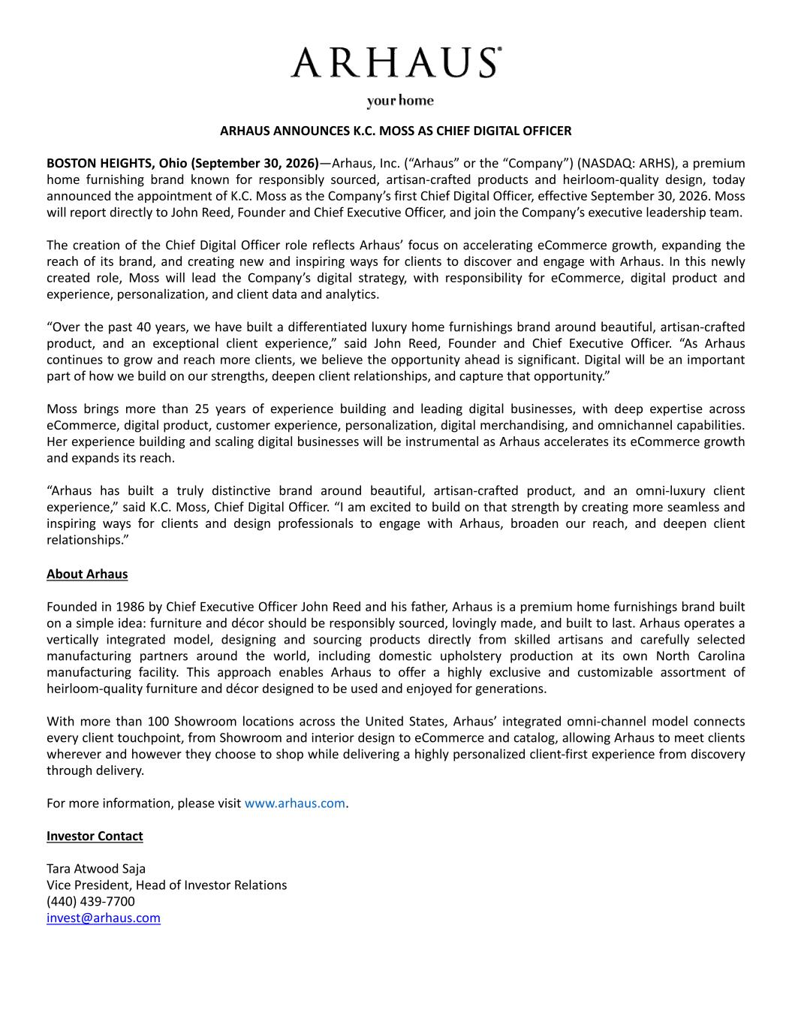

ARHAUS ANNOUNCES K.C. MOSS AS CHIEF DIGITAL OFFICER BOSTON HEIGHTS, Ohio (September 30, 2026)—Arhaus, Inc. (“Arhaus” or the “Company”) (NASDAQ: ARHS), a premium home furnishing brand known for responsibly sourced, artisan-crafted products and heirloom-quality design, today announced the appointment of K.C. Moss as the Company’s first Chief Digital Officer, effective September 30, 2026. Moss will report directly to John Reed, Founder and Chief Executive Officer, and join the Company’s executive leadership team. The creation of the Chief Digital Officer role reflects Arhaus’ focus on accelerating eCommerce growth, expanding the reach of its brand, and creating new and inspiring ways for clients to discover and engage with Arhaus. In this newly created role, Moss will lead the Company’s digital strategy, with responsibility for eCommerce, digital product and experience, personalization, and client data and analytics. “Over the past 40 years, we have built a differentiated luxury home furnishings brand around beautiful, artisan-crafted product, and an exceptional client experience,” said John Reed, Founder and Chief Executive Officer. “As Arhaus continues to grow and reach more clients, we believe the opportunity ahead is significant. Digital will be an important part of how we build on our strengths, deepen client relationships, and capture that opportunity.” Moss brings more than 25 years of experience building and leading digital businesses, with deep expertise across eCommerce, digital product, customer experience, personalization, digital merchandising, and omnichannel capabilities. Her experience building and scaling digital businesses will be instrumental as Arhaus accelerates its eCommerce growth and expands its reach. “Arhaus has built a truly distinctive brand around beautiful, artisan-crafted product, and an omni-luxury client experience,” said K.C. Moss, Chief Digital Officer. “I am excited to build on that strength by creating more seamless and inspiring ways for clients and design professionals to engage with Arhaus, broaden our reach, and deepen client relationships.” About Arhaus Founded in 1986 by Chief Executive Officer John Reed and his father, Arhaus is a premium home furnishings brand built on a simple idea: furniture and décor should be responsibly sourced, lovingly made, and built to last. Arhaus operates a vertically integrated model, designing and sourcing products directly from skilled artisans and carefully selected manufacturing partners around the world, including domestic upholstery production at its own North Carolina manufacturing facility. This approach enables Arhaus to offer a highly exclusive and customizable assortment of heirloom-quality furniture and décor designed to be used and enjoyed for generations. With more than 100 Showroom locations across the United States, Arhaus’ integrated omni-channel model connects every client touchpoint, from Showroom and interior design to eCommerce and catalog, allowing Arhaus to meet clients wherever and however they choose to shop while delivering a highly personalized client-first experience from discovery through delivery. For more information, please visit www.arhaus.com. Investor Contact Tara Atwood Saja Vice President, Head of Investor Relations (440) 439-7700 invest@arhaus.com

