UNITED STATES
SECURITIES AND EXCHANGE COMMISSION
Washington, D.C. 20549
___________________________________
FORM 8-K
___________________________________
CURRENT REPORT
Pursuant to Section 13 or 15(d)
of the Securities Exchange Act of 1934

Date of Report (date of earliest event reported): August 6, 2026
___________________________________
Arhaus, Inc.
(Exact name of registrant as specified in its charter)
___________________________________

Delaware  (State or other jurisdiction of  incorporation or organization) |  |  | 001-41009  (Commission File Number) |  |  | 87-1729256  (I.R.S. Employer Identification Number)
51 E. Hines Hill Road, Boston Heights, Ohio
(Address of Principal Executive Offices)
44236
(Zip Code)
(440) 439-7700
(Registrant's telephone number, including area code)

Check the appropriate box below if the Form 8-K filing is intended to simultaneously satisfy the filing obligation of the registrant under any of the following provisions:

☐ |  |  | Written communications pursuant to Rule 425 under the Securities Act (17 CFR 230.425)
☐ |  |  | Soliciting material pursuant to Rule 14a-12 under the Exchange Act (17 CFR 240.14a-12)
☐ |  |  | Pre-commencement communications pursuant to Rule 14d-2(b) under the Exchange Act (17 CFR 240.14d-2(b))
☐ |  |  | Pre-commencement communications pursuant to Rule 13e-4(c) under the Exchange Act (17 CFR 240.13e-4(c))
Securities registered pursuant to Section 12(b) of the Act:
Title of each class |  |  | Trading Symbol |  |  | Name of each exchange on which registered
Class A common stock, $0.001 par value per share |  |  | ARHS |  |  | The Nasdaq Global Select Market
Indicate by check mark whether the registrant is an emerging growth company as defined in Rule 405 of the Securities Act of 1933 or Rule 12b-2 of the Exchange Act of 1934.
Emerging growth company ☐
If an emerging growth company, indicate by check mark if the registrant has elected not to use the extended transition period for complying with any new or revised financial accounting standards provided pursuant to Section 13(a) of the Exchange Act. ☐

Item 2.02 Results of Operations and Financial Condition
On August 6, 2026, Arhaus, Inc. (the “Company”) issued a press release announcing its financial results for the second quarter ended June 30, 2026. A copy of the release is attached as Exhibit 99.1.

Item 7.01 Regulation FD Disclosure
On August 6, 2026, the Company issued an Investor Presentation. A copy of this presentation is attached hereto as Exhibit 99.2 and is incorporated herein by reference. This presentation, as well as similar presentations the Company may issue in the future, will be posted in the Investor Relations section of the Company's website: ir.arhaus.com.

The information furnished pursuant to Item 2.02 and Exhibit 99.1 and Exhibit 99.2 of this Current Report on Form 8-K shall not be deemed to be “filed” for the purposes of Section 18 of the Securities Exchange Act of 1934, as amended (the “Exchange Act”), or otherwise subject to the liabilities of that section. The information in this Current Report shall not be incorporated by reference into any filing under the Securities Act of 1933, as amended, or the Exchange Act, whether made before or after the date of this Current Report, regardless of any general incorporation language in the filing.
Item 9.01 Financial Statements and Exhibits
(d) The following exhibits are being filed herewith:

Exhibit No. |  |  |  |  |  | Description
99.1 |  |  |  |  |  | Press release dated August 6, 2026 announcing the release of second quarter 2026 results.
99.2 |  |  |  |  |  | Investor Presentation dated August 6, 2026.
104 |  |  |  |  |  | Cover Page with Interactive Data File (embedded within the Inline XBRL document).

SIGNATURE

Pursuant to the requirements of the Securities Exchange Act of 1934, the Registrant has duly caused this report to be signed on its behalf by the undersigned hereunto duly authorized on this 6th day of August, 2026.

ARHAUS, INC.
By: |  |  | /s/ Michael Lee
Name: |  |  | Michael Lee
Title: |  |  | Chief Financial Officer


ARHAUS REPORTS SECOND QUARTER 2026 FINANCIAL RESULTS
BOSTON HEIGHTS, Ohio (August 6, 2026)—Arhaus, Inc. (“Arhaus” or the “Company”) (NASDAQ: ARHS), a premium home furnishing brand known for responsibly sourced, artisan-crafted products and heirloom-quality design, reported second quarter results for the period ended June 30, 2026.
Second Quarter 2026 Highlights
Compared to the second quarter of 2025:
•Net revenue increased 7.4% to $385 million
•Gross margin increased 16.1% to $172 million and included a $23.8 million benefit from IEEPA tariff recoveries, of which $15.5 million related to inventory sold prior to April 2026
•Selling, general and administrative expenses increased 16.1% to $118 million
•Net and comprehensive income increased 13.1% to $40 million
•Adjusted EBITDA increased 16.8% to $70 million and reflected the $23.8 million benefit from IEEPA tariff recoveries, of which $15.5 million related to inventory sold prior to April 2026
•Comparable Delivered Sales(1) increased 4.0%
•Comparable Written Sales(2) increased 12.5%

John Reed, Co-Founder and Chief Executive Officer, said:
“Exceptional product has been the foundation of Arhaus for 40 years, and our second-quarter performance reinforces how deeply clients value quality, craftsmanship, and personalization. Our newest collections are resonating, customization continues to gain momentum, and clients are engaging across our product categories. With an exciting product pipeline and compelling storytelling ahead, we believe we are well positioned to inspire more clients and continue our industry leading growth.”
Michael Lee, Chief Financial Officer, said:
“Our second-quarter performance reflected disciplined execution across the business. We delivered results above the high end of our guidance range across our key financial metrics, generated strong Comparable Written Sales, and continued making meaningful progress on our digital transformation initiatives that support the next phase of Arhaus’ growth. As we look ahead, we remain focused on disciplined execution, investing thoughtfully in the capabilities that support long-term growth, improving operational efficiency, and creating long-term value for our shareholders.”

Business Highlights
Second quarter net revenue was $385 million, an increase of 7.4% year-over-year and above the high end of the Company’s guidance range.
Comparable Delivered Sales(1) increased 4.0% in the second-quarter, also exceeding the high end of the Company’s guidance range, bringing year-to-date Comparable Delivered Sales(1) to 1.4%. Comparable Written Sales(2) increased 12.5% in the second-quarter, bringing year-to-date Comparable Written Sales(2) to 2.8%.
Showroom Highlights
At the end of the second quarter of 2026, Arhaus operated 109 Showrooms across 31 states. During the quarter, the Company completed 4 Total Showroom Projects(3), including 2 new Showrooms, with a Traditional Showroom in Ashburn, Virginia, and a Loft location in Ontario, California, 1 relocation in Westlake, Ohio, and 1 expansion in Lone Tree, Colorado. Notable updates include:
•Ashburn, Virginia – The Company opened a Traditional Showroom spanning nearly 20,000 square feet in a premium lifestyle destination. The Showroom features Arhaus’ full product assortment, extensive custom upholstery offerings, and a best-in-class design team.
•Westlake, Ohio – The Company completed the relocation of its Crocker Park showroom in Westlake, Ohio. Located in the Company’s hometown market, Crocker Park is a premier mixed-use lifestyle destination with strong demographics and a complementary luxury retail environment.
For 2026, the Company continues to expect to complete approximately 10 to 14 Total Showroom Projects(3), consisting of 4 to 6 new openings and 6 to 8 relocations, renovations, or expansions, representing Net Unit Growth(4) of mid-single-digits for the year.
Balance Sheet and Liquidity
As of June 30, 2026, the Company reported the following:
•No long-term debt.
•Cash and cash equivalents totaled $226 million, a 10.6% decrease from December 31, 2025 to June 30, 2026. This primarily reflects the $49 million special cash dividend paid in March.
•Net merchandise inventory of $354 million, a 4.3% increase from December 31, 2025 to June 30, 2026.
•Client deposits of $264 million, a 11.8% increase from December 31, 2025 to June 30, 2026.
•Net cash provided by operating activities totaled $60 million for the six months ended June 30, 2026.
•Net cash used in investing activities was $37 million for the six months ended June 30, 2026. Company-funded capital expenditures(5) were $29 million and landlord contributions were $8 million.
IEEPA Tariff Recoveries

In February 2026, the U.S. Supreme Court issued a ruling invalidating certain tariffs previously imposed under the International Emergency Economic Powers Act (“IEEPA”). Subsequently, the U.S. Court of International Trade ruled that tariffs paid under the IEEPA must be refunded in accordance with the law.

As a result, the U.S. Customs and Border Protection Agency launched a special tariff refund program to facilitate such refunds.

The Company has requested refunds of $37.8 million for IEEPA tariffs previously paid and believes recovery is probable. As of June 30, 2026, the Company recognized a receivable of $32.7 million, which is included in prepaid and other current assets within the condensed consolidated balance sheets. As of June 30, 2026, the Company received $5.1 million in cash for the refunds.

During the six and three months ended June 30, 2026, the Company recognized a benefit of $23.8 million for the recovery of IEEPA tariffs paid, of which $15.5 million related to inventory sold prior to April 2026 and $8.3 million related to inventory sold during the quarter, in cost of goods sold within the condensed consolidated statements of comprehensive income.

As of June 30, 2026, the Company recorded $14.0 million primarily related to the reductions in inventory costs in merchandise inventory, net within the condensed consolidated balance sheets.

As of August 6, 2026, the Company has received $37.8 million in tariff refunds and $1.3 million in interest.

Outlook

The Company is maintaining its full-year Net revenue and Comparable Delivered Sales outlook. The outlook continues to reflect uncertainty related to the consumer environment, geopolitical conditions, and the timing of written sales conversion to delivered sales. The Company is updating its full-year Net income and Adjusted EBITDA outlook to reflect the benefit recognized from the recovery of previously paid IEEPA tariffs. Consistent with its long-term capital allocation philosophy, the Company expects to reinvest a portion of these recoveries into strategic growth initiatives while also offsetting elevated operating costs, with the remaining benefit reflected in updated profitability guidance.

 |  |  |  |  |  | Full-Year 2026 |  |  |  |  |  | Q3 2026
Net revenue |  |  |  |  |  | $1.43 billion to $1.47 billion |  |  |  |  |  | $355 million to $375 million
Net revenue growth |  |  |  |  |  | 3.7% to 6.6% |  |  |  |  |  | 3.0% to 8.8%
Comparable delivered sales(1) |  |  |  |  |  | 0% to 3% |  |  |  |  |  | (1)% to 5%
Net income(6) |  |  |  |  |  | $71 million to $80 million |  |  |  |  |  | $8 million to $13 million
Adjusted EBITDA(7) |  |  |  |  |  | $160 million to $171 million |  |  |  |  |  | $26 million to $34 million
Other Estimates
Company-funded capital expenditures(5) |  |  |  |  |  | $70 million to $90 million
Depreciation & amortization |  |  |  |  |  | $50 million to $55 million
Fully diluted shares |  |  |  |  |  | ~ 142 million
Effective tax rate |  |  |  |  |  | ~ 29.0%
Showroom openings |  |  |  |  |  | 4 to 6 new Showrooms
Total Showroom Projects(3) |  |  |  |  |  | 10 to 14 Showroom Projects
Net Unit Growth(4) |  |  |  |  |  | Mid-Single-Digit

(1) Comparable Delivered Sales previously referred to as “Comparable Growth” is a key performance indicator and is defined as the year-over-year percentage change of the dollar value of orders delivered (based on purchase price), net of the dollar value of returns (based on amount credited to client), from our comparable Showrooms and eCommerce, including through our catalogs and other mailings.
(2) Comparable Written Sales previously referred to as “Demand Comparable Growth” is a key performance indicator and is defined as the year-over-year percentage change of written sales from our comparable Showrooms and eCommerce, including through our catalogs and other mailings.
(3) Total Showroom Projects is defined as the number of Showroom projects completed during the period, including new Showroom openings, relocations, remodels, and expansions. The Company considers all Showroom projects integral to its long-term growth strategy, with each evaluated based on strategic relevance and expected return on investment.
(4) Net Unit Growth reflects the percentage change in total Showroom count during the period, calculated as new Showroom openings net of Showroom closures or relocations that do not increase total unit count.
(5) Company-funded capital expenditures is defined as total net cash used in investing activities less landlord contributions.
(6) U.S. GAAP net income (loss).
(7) We have not reconciled guidance for Adjusted EBITDA to the corresponding GAAP financial measure because we do not provide guidance for the various reconciling items. These items include, but are not limited to, future share-based compensation expense, income taxes, interest income, and transaction costs. We are unable to provide guidance for these reconciling items because we cannot determine their probable significance, as certain items are outside of our control and cannot be reasonably predicted due to the fact that these items could vary significantly from period to period. Accordingly, reconciliations to the corresponding GAAP financial measure is not available without unreasonable effort
Conference Call
You are invited to listen to Arhaus’ conference call to discuss the second quarter 2026 financial results scheduled for today, August 6, 2026, at 8:30 a.m. Eastern Time. The call will be available over the Internet on our website (http://ir.arhaus.com) or by dialing (877) 407-3982 within the U.S., or 1 (201) 493-6780, outside the U.S. The conference ID number is 13758507.
A recorded replay of the conference call will be available within approximately three hours of the conclusion of the call and can be accessed online at http://ir.arhaus.com for approximately twelve months.
About Arhaus
Founded in 1986 by Chief Executive Officer John Reed and his father, Arhaus is a premium home furnishings brand built on a simple idea: furniture and décor should be responsibly sourced, lovingly made, and built to last. Arhaus operates a vertically integrated model, designing and sourcing products directly from skilled artisans and carefully selected manufacturing partners around the world, including domestic upholstery production at its own North Carolina manufacturing facility. This approach enables Arhaus to offer a highly exclusive and customizable assortment of heirloom-quality furniture and décor designed to be used and enjoyed for generations.

With more than 100 Showroom locations across the United States, Arhaus’ integrated omni-channel model connects every client touchpoint, from Showroom and interior design to eCommerce and catalog, allowing Arhaus to meet clients wherever and however they choose to shop while delivering a highly personalized client-first experience from discovery through delivery.

For more information, please visit www.arhaus.com.
Investor Contact:
Tara Atwood Saja
Vice President, Investor Relations
(440) 439-7700
invest@arhaus.com

Non-GAAP Financial Measures
In addition to the results provided in accordance with U.S. GAAP, this press release and related tables include adjusted EBITDA, adjusted EBITDA as a percentage of net revenue, and Free Cash Flow, which present operating results on an adjusted basis.

We use non-GAAP measures to help assess the performance of our business, identify trends affecting our business, formulate business plans and make strategic decisions. In addition to our results determined in accordance with U.S. GAAP, we believe that providing these non-GAAP financial measures is useful to our investors as they present an informative supplemental view of our results from period to period by removing the effect of non-recurring items. However, our inclusion of these adjusted measures should not be construed as an indication that our future results will be unaffected by unusual or infrequent items or that the items for which we have made adjustments are unusual or infrequent or will not recur. These non-U.S. GAAP measures are not a substitute for, or superior to, measures of financial performance prepared in accordance with U.S. GAAP. Because not all companies use identical calculations, the presentations of these measures may not be comparable to other similarly titled measures of other companies and can differ significantly from company to company. These measures should only be read together with the corresponding U.S. GAAP measures. Please refer to the reconciliations of adjusted EBITDA and Free Cash Flow to the most directly comparable financial measures prepared in accordance with U.S. GAAP below.
Forward-Looking Statements
Certain statements contained herein, including statements under the heading “Outlook” are not based on historical fact and are “forward-looking statements” within the meaning of applicable securities laws.

Forward-looking statements can generally be identified by the use of forward-looking terminology, including, but not limited to, “may,” “could,” “seek,” “guidance,” “predict,” “potential,” “likely,” “believe,” “will,” “expect,” “anticipate,” “estimate,” “plan,” “intend,” “forecast,” or variations of these terms and similar expressions, or the negative of these terms or similar expressions. Past performance is not a guarantee of future results or returns and no representation or warranty is made regarding future performance. Such forward-looking statements involve known and unknown risks, uncertainties and other important factors beyond our control that could cause our actual results, performance or achievements to be materially different from the expected results, performance or achievements expressed or implied by such forward-looking statements. These risks and uncertainties include, but are not limited to: our ability to manage and maintain the growth rate of our business; our ability to obtain quality merchandise in sufficient quantities; challenges with the planning or implementation of our technology upgrades, including a new enterprise resource planning system; disruption in our receiving and distribution system, including delays in the integration of our distribution centers and the possibility that we may not realize the anticipated benefits of multiple distribution centers; effects of new or proposed tariffs and changes to international trade policies and agreements; the possibility of cyberattacks and our ability to maintain adequate cybersecurity systems and procedures; loss, corruption and misappropriation of data and information relating to clients and employees; changes in and compliance with applicable data privacy rules and regulations; risks as a result of constraints in our supply chain or disruptions due to geopolitical events such as acts of war and/or terrorism or other hostilities; a failure of our vendors to meet our quality standards; declines in general economic conditions that affect consumer confidence and consumer spending that could adversely affect our revenue; our ability to anticipate changes in consumer preferences; risks related to maintaining and increasing Showroom traffic and sales; our ability to compete in our market; our ability to adequately protect our intellectual property; compliance with applicable governmental regulations; effectively managing our eCommerce sales channel and digital marketing efforts; our reliance on third-party transportation carriers and risks associated with freight and transportation costs; and compliance with SEC rules and regulations as a public reporting company. These factors should not be construed as exhaustive. Further information on potential factors that could affect the financial results of the Company and its forward-looking statements is included in the Company’s filings with the Securities and Exchange Commission. The Company assumes no obligation to update any forward-looking statement, except as may be required by law. These forward-looking statements speak only as of the date of this release. All forward-looking statements are qualified in their entirety by this cautionary statement.

Arhaus, Inc. and Subsidiaries

Condensed Consolidated Balance Sheets
(Unaudited, amounts in thousands, except share and per share data)

 |  |  | June 30,  2026 |  |  |  |  |  | December 31,  2025
Assets
Current assets
Cash and cash equivalents |  |  | $ | 226,399 |  |  |  |  | $ | 253,356
Restricted cash |  |  | 1,286 |  |  |  |  |  | 3,124
Accounts receivable, net |  |  | 236 |  |  |  |  |  | 663
Merchandise inventory, net |  |  | 353,531 |  |  |  |  |  | 338,806
Prepaid and other current assets |  |  | 61,065 |  |  |  |  |  | 25,425
Total current assets |  |  | 642,517 |  |  |  |  |  | 621,374
Operating right-of-use assets |  |  | 415,884 |  |  |  |  |  | 391,274
Financing right-of-use assets |  |  | 32,184 |  |  |  |  |  | 33,275
Property, furniture and equipment, net |  |  | 331,038 |  |  |  |  |  | 316,216
Deferred tax assets |  |  | 15,386 |  |  |  |  |  | 19,545
Goodwill |  |  | 10,961 |  |  |  |  |  | 10,961
Other noncurrent assets |  |  | 2,483 |  |  |  |  |  | 2,101
Total assets |  |  | $ | 1,450,453 |  |  |  |  | $ | 1,394,746
Liabilities and Stockholders’ Equity
Current liabilities
Accounts payable |  |  | $ | 71,910 |  |  |  |  | $ | 78,360
Accrued taxes |  |  | 12,825 |  |  |  |  |  | 10,322
Accrued wages |  |  | 19,447 |  |  |  |  |  | 20,879
Accrued other expenses |  |  | 53,269 |  |  |  |  |  | 46,781
Client deposits |  |  | 263,787 |  |  |  |  |  | 235,943
Current portion of operating lease liabilities |  |  | 62,156 |  |  |  |  |  | 60,115
Current portion of financing lease liabilities |  |  | 970 |  |  |  |  |  | 862
Total current liabilities |  |  | 484,364 |  |  |  |  |  | 453,262
Operating lease liabilities, long-term |  |  | 494,179 |  |  |  |  |  | 467,226
Financing lease liabilities, long-term |  |  | 51,931 |  |  |  |  |  | 52,374
Other long-term liabilities |  |  | 5,032 |  |  |  |  |  | 3,656
Total liabilities |  |  | $ | 1,035,506 |  |  |  |  | $ | 976,518
Commitments and contingencies (Note 9)
Stockholders’ equity
Class A shares, par value $0.001 per share (600,000,000 shares authorized, 55,439,727 shares issued and 54,609,412 outstanding as of June 30, 2026; 54,565,242 shares issued and 53,969,149 outstanding as of December 31, 2025) |  |  | 55 |  |  |  |  |  | 54
Class B shares, par value $0.001 per share (100,000,000 shares authorized, 87,115,600 shares issued and outstanding as of June 30, 2026; 87,115,600 shares issued and outstanding as of December 31, 2025) |  |  | 87 |  |  |  |  |  | 87
Retained earnings |  |  | 202,037 |  |  |  |  |  | 210,365
Additional paid-in capital |  |  | 212,768 |  |  |  |  |  | 207,722
Total stockholders’ equity |  |  | 414,947 |  |  |  |  |  | 418,228
Total liabilities and stockholders’ equity |  |  | $ | 1,450,453 |  |  |  |  | $ | 1,394,746

Arhaus, Inc. and Subsidiaries

Condensed Consolidated Statements of Comprehensive Income
(Unaudited, amounts in thousands, except share and per share data)
 |  |  | Six months ended |  |  |  |  |  |  |  |  |  |  |  | Three months ended
 |  |  | June 30, |  |  |  |  |  |  |  |  |  |  |  | June 30,
 |  |  | 2026 |  |  |  |  |  | 2025 |  |  |  |  |  | 2026 |  |  |  |  |  | 2025
Net revenue |  |  | $ | 699,173 |  |  |  |  | $ | 669,807 |  |  |  |  | $ | 384,897 |  |  |  |  | $ | 358,435
Cost of goods sold |  |  | 412,665 |  |  |  |  |  | 405,993 |  |  |  |  |  | 212,824 |  |  |  |  |  | 210,208
Gross margin |  |  | 286,508 |  |  |  |  |  | 263,814 |  |  |  |  |  | 172,073 |  |  |  |  |  | 148,227
Selling, general and administrative expenses |  |  | 230,002 |  |  |  |  |  | 211,520 |  |  |  |  |  | 117,807 |  |  |  |  |  | 101,462
Loss on disposal of assets |  |  | 104 |  |  |  |  |  | 108 |  |  |  |  |  | — |  |  |  |  |  | —
Income from operations |  |  | $ | 56,402 |  |  |  |  | $ | 52,186 |  |  |  |  | $ | 54,266 |  |  |  |  | $ | 46,765
Interest income, net |  |  | (1,518) |  |  |  |  |  | (1,317) |  |  |  |  |  | (1,064) |  |  |  |  |  | (744)
Other income |  |  | (892) |  |  |  |  |  | (236) |  |  |  |  |  | (45) |  |  |  |  |  | (150)
Income before taxes |  |  | 58,812 |  |  |  |  |  | 53,739 |  |  |  |  |  | 55,375 |  |  |  |  |  | 47,659
Income tax expense |  |  | 16,943 |  |  |  |  |  | 13,791 |  |  |  |  |  | 15,729 |  |  |  |  |  | 12,593
Net and comprehensive income |  |  | $ | 41,869 |  |  |  |  | $ | 39,948 |  |  |  |  | $ | 39,646 |  |  |  |  | $ | 35,066
Net and comprehensive income per share, basic
Weighted-average number of common shares outstanding, basic |  |  | 141,218,014 |  |  |  |  |  | 140,536,663 |  |  |  |  |  | 141,466,361 |  |  |  |  |  | 140,709,814
Net and comprehensive income per share, basic |  |  | $ | 0.30 |  |  |  |  | $ | 0.28 |  |  |  |  | $ | 0.28 |  |  |  |  | $ | 0.25
Net and comprehensive income per share, diluted
Weighted-average number of common shares outstanding, diluted |  |  | 141,776,353 |  |  |  |  |  | 141,126,879 |  |  |  |  |  | 141,808,253 |  |  |  |  |  | 141,162,310
Net and comprehensive income per share, diluted |  |  | $ | 0.30 |  |  |  |  | $ | 0.28 |  |  |  |  | $ | 0.28 |  |  |  |  | $ | 0.25

Arhaus, Inc. and Subsidiaries

Condensed Consolidated Statements of Cash Flows
(Unaudited, amounts in thousands)
 |  |  | Six months ended
 |  |  | June 30,
 |  |  | 2026 |  |  |  |  |  | 2025
Cash flows from operating activities
Net income |  |  | $ | 41,869 |  |  |  |  | $ | 39,948
Adjustments to reconcile net income to net cash provided by operating activities
Depreciation and amortization |  |  | 25,114 |  |  |  |  |  | 22,959
Amortization of operating lease right-of-use asset |  |  | 24,181 |  |  |  |  |  | 20,335
Amortization of interest on operating leases |  |  | 16,004 |  |  |  |  |  | 14,156
Equity based compensation |  |  | 6,058 |  |  |  |  |  | 3,390
Deferred tax assets |  |  | 4,159 |  |  |  |  |  | (1,529)
Amortization of cloud computing arrangements |  |  | 1,749 |  |  |  |  |  | 853
Loss on disposal of assets |  |  | 104 |  |  |  |  |  | 108
Insurance proceeds |  |  | 176 |  |  |  |  |  | —
Gain on insurance claims |  |  | (952) |  |  |  |  |  | —
Changes in operating assets and liabilities
Accounts receivable |  |  | 427 |  |  |  |  |  | 282
Merchandise inventory |  |  | (14,725) |  |  |  |  |  | (14,107)
Prepaid and other assets |  |  | (38,214) |  |  |  |  |  | 4,398
Other noncurrent liabilities |  |  | 1,378 |  |  |  |  |  | (172)
Accounts payable |  |  | (8,254) |  |  |  |  |  | 1,816
Accrued expenses |  |  | 8,108 |  |  |  |  |  | 4,746
Operating lease liabilities |  |  | (35,242) |  |  |  |  |  | (27,952)
Client deposits |  |  | 27,844 |  |  |  |  |  | 12,197
Net cash provided by operating activities |  |  | 59,784 |  |  |  |  |  | 81,428
Cash flows from investing activities
Purchases of property, furniture and equipment |  |  | (38,093) |  |  |  |  |  | (41,622)
Insurance proceeds |  |  | 1,193 |  |  |  |  |  | —
Net cash used in investing activities |  |  | (36,900) |  |  |  |  |  | (41,622)
Cash flows from financing activities
Principal payments under finance leases |  |  | (425) |  |  |  |  |  | (365)
Repurchase of shares for payment of withholding taxes for equity based compensation |  |  | (1,664) |  |  |  |  |  | (1,675)
Cash dividend payments |  |  | (49,590) |  |  |  |  |  | (276)
Net cash used in financing activities |  |  | (51,679) |  |  |  |  |  | (2,316)
Net (decrease) increase in cash, cash equivalents and restricted cash |  |  | (28,795) |  |  |  |  |  | 37,490
Cash, cash equivalents and restricted cash
Beginning of period |  |  | 256,480 |  |  |  |  |  | 200,929
End of period |  |  | $ | 227,685 |  |  |  |  | $ | 238,419
Supplemental disclosure of cash flow information
Interest paid in cash |  |  | $ | 2,630 |  |  |  |  | $ | 2,513
Interest received in cash |  |  | 3,539 |  |  |  |  |  | 4,040
Income taxes paid in cash |  |  | 8,628 |  |  |  |  |  | 13,030
Noncash investing activities:
Purchases of property, furniture and equipment in current liabilities |  |  | 10,907 |  |  |  |  |  | 7,190

Arhaus, Inc. and Subsidiaries

Reconciliation of Net Income to Adjusted EBITDA
(Unaudited, amounts in thousands)
 |  |  | Six months ended |  |  |  |  |  |  |  |  |  |  |  | Three months ended
 |  |  | June 30, |  |  |  |  |  |  |  |  |  |  |  | June 30,
 |  |  | 2026 |  |  |  |  |  | 2025 |  |  |  |  |  | 2026 |  |  |  |  |  | 2025
Net and comprehensive income |  |  | $ | 41,869 |  |  |  |  | $ | 39,948 |  |  |  |  | $ | 39,646 |  |  |  |  | $ | 35,066
Interest income, net |  |  | (1,518) |  |  |  |  |  | (1,317) |  |  |  |  |  | (1,064) |  |  |  |  |  | (744)
Income tax expense |  |  | 16,943 |  |  |  |  |  | 13,791 |  |  |  |  |  | 15,729 |  |  |  |  |  | 12,593
Depreciation and amortization |  |  | 25,114 |  |  |  |  |  | 22,959 |  |  |  |  |  | 12,744 |  |  |  |  |  | 11,597
EBITDA |  |  | 82,408 |  |  |  |  |  | 75,381 |  |  |  |  |  | 67,055 |  |  |  |  |  | 58,512
Equity based compensation |  |  | 6,058 |  |  |  |  |  | 3,390 |  |  |  |  |  | 3,413 |  |  |  |  |  | 1,795
Other expenses (1) |  |  | — |  |  |  |  |  | 108 |  |  |  |  |  | — |  |  |  |  |  | —
Adjusted EBITDA |  |  | $ | 88,466 |  |  |  |  | $ | 78,879 |  |  |  |  | $ | 70,468 |  |  |  |  | $ | 60,307
Net revenue |  |  | $ | 699,173 |  |  |  |  | $ | 669,807 |  |  |  |  | $ | 384,897 |  |  |  |  | $ | 358,435
Net and comprehensive income as a % of net revenue |  |  | 6.0 |  | % |  |  |  | 6.0 |  | % |  |  |  | 10.3 |  | % |  |  |  | 9.8 |  | %
Adjusted EBITDA as a % of net revenue |  |  | 12.7 |  | % |  |  |  | 11.8 |  | % |  |  |  | 18.3 |  | % |  |  |  | 16.8 |  | %
(1) Other expenses represent costs and investments not indicative of ongoing business performance, such as loss on disposal of assets.

Arhaus, Inc. and Subsidiaries

Reconciliation of Free Cash Flow
(Unaudited, amounts in thousands)
 |  |  | Six months ended
 |  |  | June 30,
 |  |  | 2026 |  |  |  |  |  | 2025
Net cash provided by operating activities |  |  | $ | 59,784 |  |  |  |  | $ | 81,428
Net cash used in investing activities |  |  | (36,900) |  |  |  |  |  | (41,622)
Free cash flow |  |  | $ | 22,884 |  |  |  |  | $ | 39,806

Free Cash Flow is defined as net cash provided by operating activities less net cash used in investing activities.

Arhaus, Inc. and Subsidiaries

Supplemental Comparable Metrics Schedules
(Unaudited)
Supplemental Comparable Metrics Schedules

Comparable Written Sales(2) by Quarter and Year-to-Date

The table below represents Comparable Written Sales(2) on a quarterly and year-to-date basis for fiscal year 2026. Comparable Written Sales(2) reflects written sales trends during the period and is measured using a 13-month comparable Showroom definition, consistent with historical disclosure.

2026 |  |  |  |  |  | Comparable Written Sales  (By Quarter) |  |  |  |  |  | Comparable Written Sales  (Year-to-Date)
First Quarter |  |  |  |  |  | (5.7) |  | % |  |  |  | (5.7) |  | %
Second Quarter |  |  |  |  |  | 12.5 |  | % |  |  |  | 2.8 |  | %

Comparable Delivered Sales(1) by Quarter and Year-to-Date

The table below represents Comparable Delivered Sales(1) on a quarterly and year-to-date basis for fiscal year 2026. Comparable Delivered Sales(1) reflects revenue recognized during the period and is measured using a 15-month comparable Showroom definition, consistent with historical disclosure.

2026 |  |  |  |  |  | Comparable Delivered Sales  (By Quarter) |  |  |  |  |  | Comparable Delivered Sales  (Year-to-Date)
First Quarter |  |  |  |  |  | (1.7) |  | % |  |  |  | (1.7) |  | %
Second Quarter |  |  |  |  |  | 4.0 |  | % |  |  |  | 1.4 |  | %

Due to differences in order timing, backlog, and revenue recognition, Comparable Written Sales(2) and Comparable Delivered Sales(1) use different comparable Showroom eligibility thresholds. Comparable Written Sales(2) metrics use a 13-month definition to reflect written sales trends, while Comparable Delivered Sales(1) metrics use a 15-month definition to reflect revenue recognition consistency.

Arhaus, Inc. and Subsidiaries

Supplemental Showroom Schedules
(Unaudited)
Supplemental Showroom Schedules

Showroom Portfolio Composition

The table below represents the composition of the Showroom Portfolio by format and operating footprint as of each period presented:

 |  |  | June 30,  2026 |  |  |  |  |  | December 31,  2025
Traditional Showrooms |  |  | 91 |  |  |  |  |  | 90
Design Studios |  |  | 9 |  |  |  |  |  | 9
Lofts |  |  | 9 |  |  |  |  |  | 8
Total Showrooms |  |  | 109 |  |  |  |  |  | 107
Total gross square footage (in thousands) |  |  | 1,897 |  |  |  |  |  | 1,836
Showrooms with interior designers |  |  | 97 |  |  |  |  |  | 97
Total interior designers |  |  | 152 |  |  |  |  |  | 142
States where we operate |  |  | 31 |  |  |  |  |  | 31

Geographic Showroom Footprint

The table below represents the number of Showrooms in each U.S. state in which the Company operates as of June 30, 2026.

Locations |  |  |  |  |  | Showrooms |  |  |  |  |  | Locations |  |  |  |  |  | Showrooms
Alabama |  |  |  |  |  | 1 |  |  |  |  |  | Missouri |  |  |  |  |  | 1
Arizona |  |  |  |  |  | 2 |  |  |  |  |  | Montana |  |  |  |  |  | 1
California |  |  |  |  |  | 17 |  |  |  |  |  | New Hampshire |  |  |  |  |  | 1
Colorado |  |  |  |  |  | 6 |  |  |  |  |  | New Jersey |  |  |  |  |  | 5
Connecticut |  |  |  |  |  | 3 |  |  |  |  |  | New York |  |  |  |  |  | 4
Florida |  |  |  |  |  | 9 |  |  |  |  |  | North Carolina |  |  |  |  |  | 4
Georgia |  |  |  |  |  | 3 |  |  |  |  |  | Ohio |  |  |  |  |  | 9
Illinois |  |  |  |  |  | 4 |  |  |  |  |  | Oklahoma |  |  |  |  |  | 1
Indiana |  |  |  |  |  | 1 |  |  |  |  |  | Pennsylvania |  |  |  |  |  | 4
Kansas |  |  |  |  |  | 1 |  |  |  |  |  | South Carolina |  |  |  |  |  | 1
Kentucky |  |  |  |  |  | 3 |  |  |  |  |  | Tennessee |  |  |  |  |  | 1
Louisiana |  |  |  |  |  | 1 |  |  |  |  |  | Texas |  |  |  |  |  | 8
Maryland |  |  |  |  |  | 4 |  |  |  |  |  | Utah |  |  |  |  |  | 1
Massachusetts |  |  |  |  |  | 3 |  |  |  |  |  | Virginia |  |  |  |  |  | 5
Michigan |  |  |  |  |  | 3 |  |  |  |  |  | Wisconsin |  |  |  |  |  | 1
Minnesota |  |  |  |  |  | 1

Arhaus, Inc. and Subsidiaries

Supplemental Showroom Schedules
(Unaudited)

Showroom Maturity Mix

The table below represents the composition of the Showroom portfolio by maturity as of the period presented.

June 30, 2026
Maturity Bucket |  |  |  |  |  | Definition |  |  |  |  |  | % of Portfolio |  |  |  |  |  | # of Showrooms
< 12 Months |  |  |  |  |  | Opened within Last 12 Months |  |  |  |  |  | 7 |  | % |  |  |  | 8
12-24 Months |  |  |  |  |  | Opened 12 to 24 Months |  |  |  |  |  | 14 |  | % |  |  |  | 15
24-36 Months |  |  |  |  |  | Opened 24 to 36 Months |  |  |  |  |  | 15 |  | % |  |  |  | 16
> 36 Months |  |  |  |  |  | Mature Showrooms |  |  |  |  |  | 64 |  | % |  |  |  | 70
Total |  |  |  |  |  |  |  |  |  |  |  | 100 |  | % |  |  |  | 109

The elevated proportion of newer showrooms reflects increased openings and relocations over the past several years and supports embedded future revenue growth as locations mature. Maturity is measured from Showroom opening date or relocation reopening date; includes Traditional Showrooms, Design Studios, and Lofts; excludes temporary closures.

Illustrative Unit Economics (Targets)

The table below represents targeted Showroom unit economics at maturity, based on internal underwriting assumptions and historical performance.

Metric |  |  |  |  |  | Traditional Showroom |  |  |  |  |  | Design Studio
 |  |  |  |  |  | (~17K sq ft) |  |  |  |  |  | (~6K sq ft)
Net Revenue Maturity |  |  |  |  |  | > $10M |  |  |  |  |  | Lower than Traditional
Contribution Margin (pre-D&A) |  |  |  |  |  | ~32% |  |  |  |  |  | ~35%
Cash Payback |  |  |  |  |  | < 2 years |  |  |  |  |  | < 2 years
Company-funded capital expenditures |  |  |  |  |  | ~$4 - 6M |  |  |  |  |  | Lower
Revenue Maturity |  |  |  |  |  | Year 3 |  |  |  |  |  | Year 3

Company-funded capital expenditures represents the total net cash used in investing activities less landlord contributions. Targets reflect performance at full maturity. Assumptions are informed by historical performance, internal underwriting, and recent Showroom cohorts.

Arhaus, Inc. and Subsidiaries

Supplemental Showroom Schedules
(Unaudited)
Total Showroom Projects(3)

The table below represents the total Showroom project pipeline for fiscal year 2026, consistent with the Company’s guidance.

Guidance Full-Year 2026
Project Type |  |  |  |  |  | Definition |  |  |  |  |  | # of Projects
New Openings |  |  |  |  |  | New Showroom openings |  |  |  |  |  | 4 to 6
Relocations |  |  |  |  |  | Relocation of existing Showrooms |  |  |  |  |  | 4 to 5
Renovations/Expansions |  |  |  |  |  | Refreshes of remodels and Expansions of existing Showrooms |  |  |  |  |  | 2 to 3
Total Showroom Projects |  |  |  |  |  |  |  |  |  |  |  | 10 to 14

Total Showroom Projects(3) are expected to be within the Company’s full-year 2026 guidance range. For competitive reasons, the Company does not disclose the specific locations of planned Total Showroom Projects(3). The Company provides additional detail on Showroom activity following completion as part of its regular quarterly disclosures.



INVESTOR PRESENTATION Long-Term Strategy and Q2 2026 Results August 6, 2026

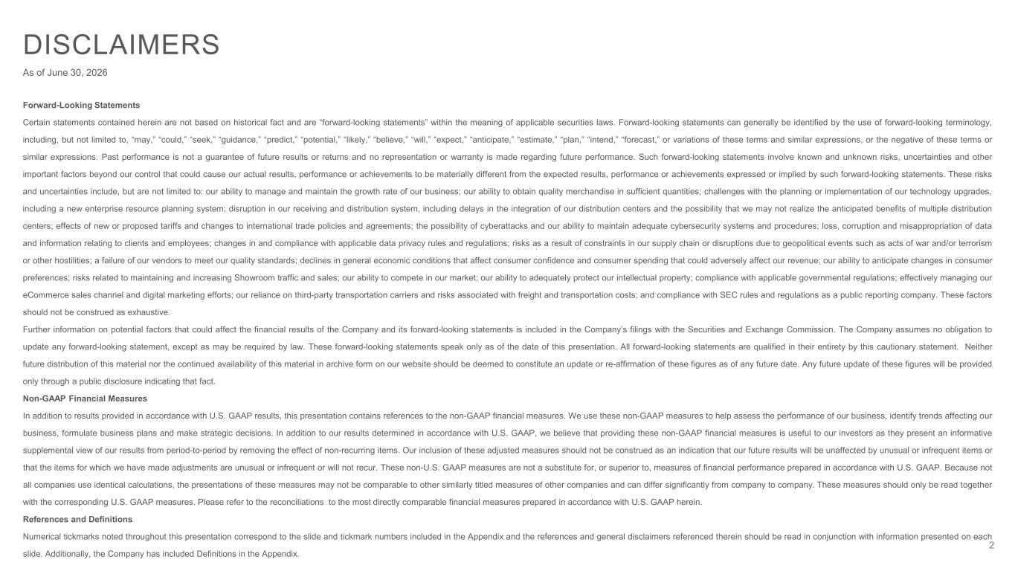
2 DISCLAIMERS As of June 30, 2026 Forward-Looking Statements Certain statements contained herein are not based on historical fact and are “forward-looking statements” within the meaning of applicable securities laws. Forward-looking statements can generally be identified by the use of forward-looking terminology, including, but not limited to, “may,” “could,” “seek,” “guidance,” “predict,” “potential,” “likely,” “believe,” “will,” “expect,” “anticipate,” “estimate,” “plan,” “intend,” “forecast,” or variations of these terms and similar expressions, or the negative of these terms or similar expressions. Past performance is not a guarantee of future results or returns and no representation or warranty is made regarding future performance. Such forward-looking statements involve known and unknown risks, uncertainties and other important factors beyond our control that could cause our actual results, performance or achievements to be materially different from the expected results, performance or achievements expressed or implied by such forward-looking statements. These risks and uncertainties include, but are not limited to: our ability to manage and maintain the growth rate of our business; our ability to obtain quality merchandise in sufficient quantities; challenges with the planning or implementation of our technology upgrades, including a new enterprise resource planning system; disruption in our receiving and distribution system, including delays in the integration of our distribution centers and the possibility that we may not realize the anticipated benefits of multiple distribution centers; effects of new or proposed tariffs and changes to international trade policies and agreements; the possibility of cyberattacks and our ability to maintain adequate cybersecurity systems and procedures; loss, corruption and misappropriation of data and information relating to clients and employees; changes in and compliance with applicable data privacy rules and regulations; risks as a result of constraints in our supply chain or disruptions due to geopolitical events such as acts of war and/or terrorism or other hostilities; a failure of our vendors to meet our quality standards; declines in general economic conditions that affect consumer confidence and consumer spending that could adversely affect our revenue; our ability to anticipate changes in consumer preferences; risks related to maintaining and increasing Showroom traffic and sales; our ability to compete in our market; our ability to adequately protect our intellectual property; compliance with applicable governmental regulations; effectively managing our eCommerce sales channel and digital marketing efforts; our reliance on third-party transportation carriers and risks associated with freight and transportation costs; and compliance with SEC rules and regulations as a public reporting company. These factors should not be construed as exhaustive. Further information on potential factors that could affect the financial results of the Company and its forward-looking statements is included in the Company’s filings with the Securities and Exchange Commission. The Company assumes no obligation to update any forward-looking statement, except as may be required by law. These forward-looking statements speak only as of the date of this presentation. All forward-looking statements are qualified in their entirety by this cautionary statement. Neither future distribution of this material nor the continued availability of this material in archive form on our website should be deemed to constitute an update or re-affirmation of these figures as of any future date. Any future update of these figures will be provided only through a public disclosure indicating that fact. Non-GAAP Financial Measures In addition to results provided in accordance with U.S. GAAP results, this presentation contains references to the non-GAAP financial measures. We use these non-GAAP measures to help assess the performance of our business, identify trends affecting our business, formulate business plans and make strategic decisions. In addition to our results determined in accordance with U.S. GAAP, we believe that providing these non-GAAP financial measures is useful to our investors as they present an informative supplemental view of our results from period-to-period by removing the effect of non-recurring items. Our inclusion of these adjusted measures should not be construed as an indication that our future results will be unaffected by unusual or infrequent items or that the items for which we have made adjustments are unusual or infrequent or will not recur. These non-U.S. GAAP measures are not a substitute for, or superior to, measures of financial performance prepared in accordance with U.S. GAAP. Because not all companies use identical calculations, the presentations of these measures may not be comparable to other similarly titled measures of other companies and can differ significantly from company to company. These measures should only be read together with the corresponding U.S. GAAP measures. Please refer to the reconciliations to the most directly comparable financial measures prepared in accordance with U.S. GAAP herein. References and Definitions Numerical tickmarks noted throughout this presentation correspond to the slide and tickmark numbers included in the Appendix and the references and general disclaimers referenced therein should be read in conjunction with information presented on each slide. Additionally, the Company has included Definitions in the Appendix.

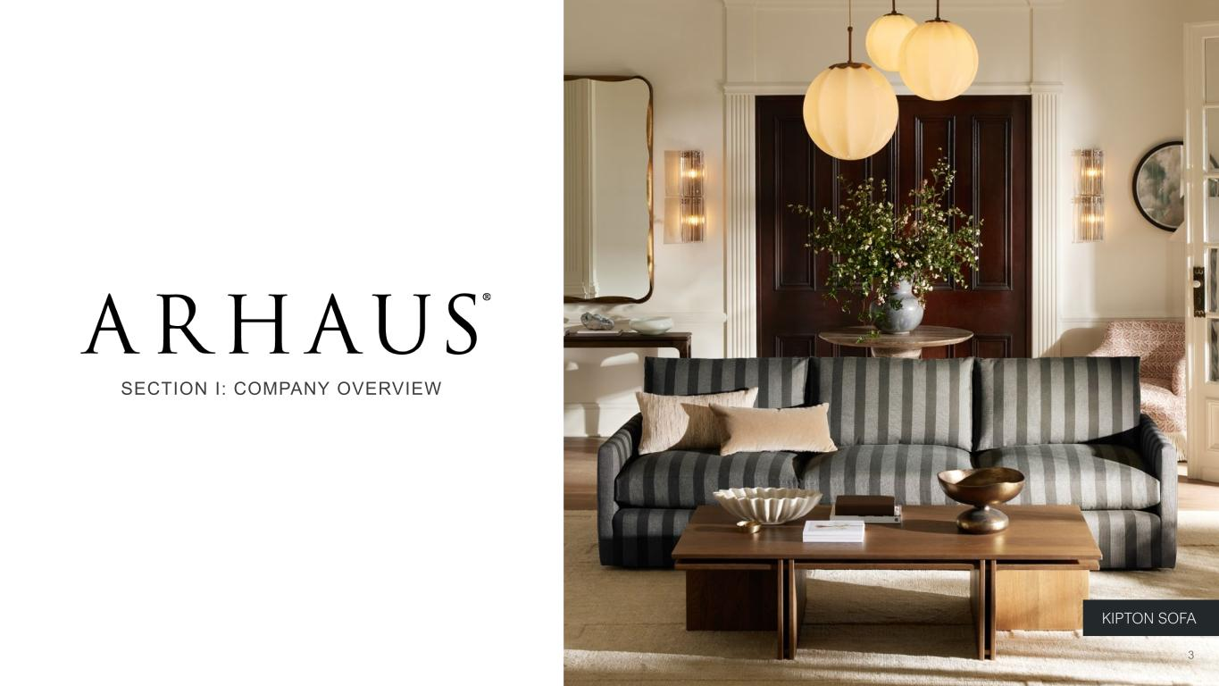
3 SECTION I: COMPANY OVERVIEW KIPTON SOFA 3


Photo: John Reed with some of our Italian vendor artisans, whom we have had relationships with for over 20 years. 4 OUR MISSION We were founded in 1986 on a simple idea: Furniture and décor should be responsibly sourced, lovingly made, and built to last for generations. 4

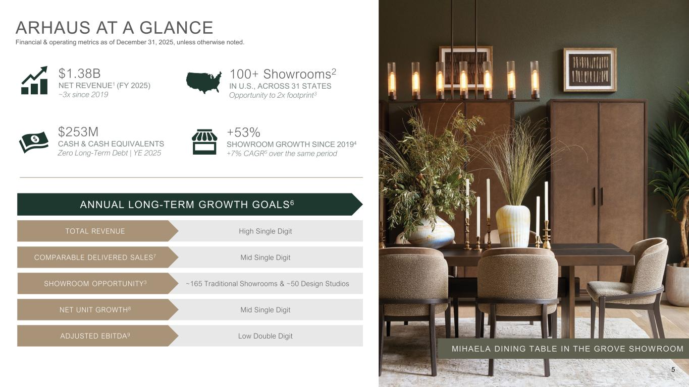
ARHAUS AT A GLANCE Financial & operating metrics as of December 31, 2025, unless otherwise noted. $1.38B NET REVENUE1 (FY 2025) ~3x since 2019 $253M CASH & CASH EQUIVALENTS Zero Long-Term Debt | YE 2025 High Single Digit ~165 Traditional Showrooms & ~50 Design Studios Mid Single Digit Low Double Digit TOTAL REVENUE SHOWROOM OPPORTUNITY3 COMPARABLE DELIVERED SALES7 ADJUSTED EBITDA9 Mid Single DigitNET UNIT GROWTH8 ANNUAL LONG-TERM GROWTH GOALS6 +53% SHOWROOM GROWTH SINCE 20194 +7% CAGR5 over the same period MIHAELA DINING TABLE IN THE GROVE SHOWROOM 100+ Showrooms2 IN U.S., ACROSS 31 STATES Opportunity to 2x footprint3 5

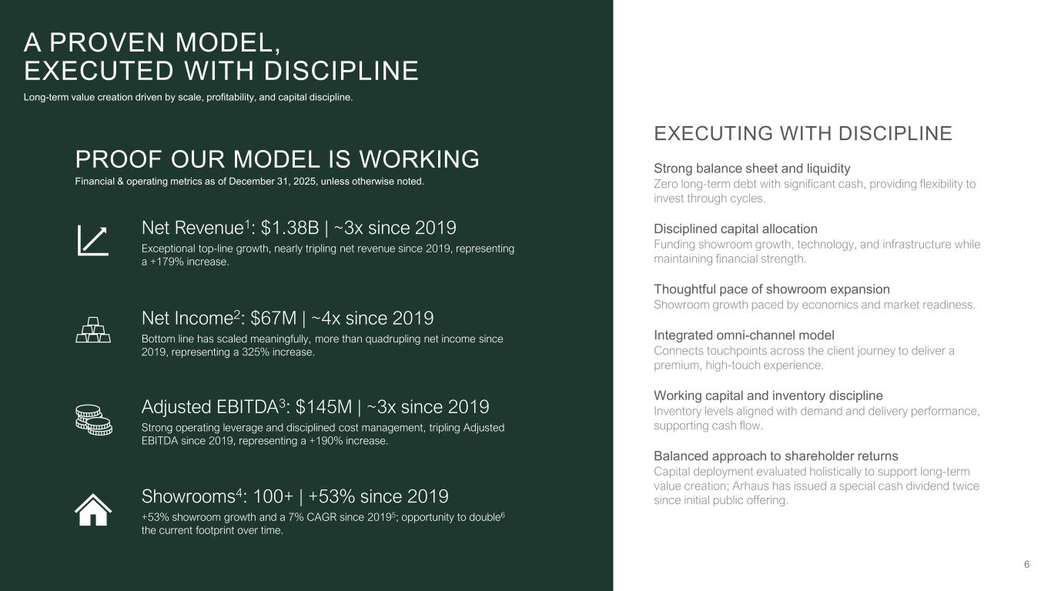
6 Adjusted EBITDA3: $145M | ~3x since 2019 Strong operating leverage and disciplined cost management, tripling Adjusted EBITDA since 2019, representing a +190% increase. Net Revenue1: $1.38B | ~3x since 2019 Exceptional top-line growth, nearly tripling net revenue since 2019, representing a +179% increase. Showrooms4: 100+ | +53% since 2019 +53% showroom growth and a 7% CAGR since 20195; opportunity to double6 the current footprint over time. EXECUTING WITH DISCIPLINE Strong balance sheet and liquidity Zero long-term debt with significant cash, providing flexibility to invest through cycles. Disciplined capital allocation Funding showroom growth, technology, and infrastructure while maintaining financial strength. Thoughtful pace of showroom expansion Showroom growth paced by economics and market readiness. Integrated omni-channel model Connects touchpoints across the client journey to deliver a premium, high-touch experience. Working capital and inventory discipline Inventory levels aligned with demand and delivery performance, supporting cash flow. Balanced approach to shareholder returns Capital deployment evaluated holistically to support long-term value creation; Arhaus has issued a special cash dividend twice since initial public offering. A PROVEN MODEL, EXECUTED WITH DISCIPLINE Long-term value creation driven by scale, profitability, and capital discipline. PROOF OUR MODEL IS WORKING Financial & operating metrics as of December 31, 2025, unless otherwise noted. Net Income2: $67M | ~4x since 2019 Bottom line has scaled meaningfully, more than quadrupling net income since 2019, representing a 325% increase.

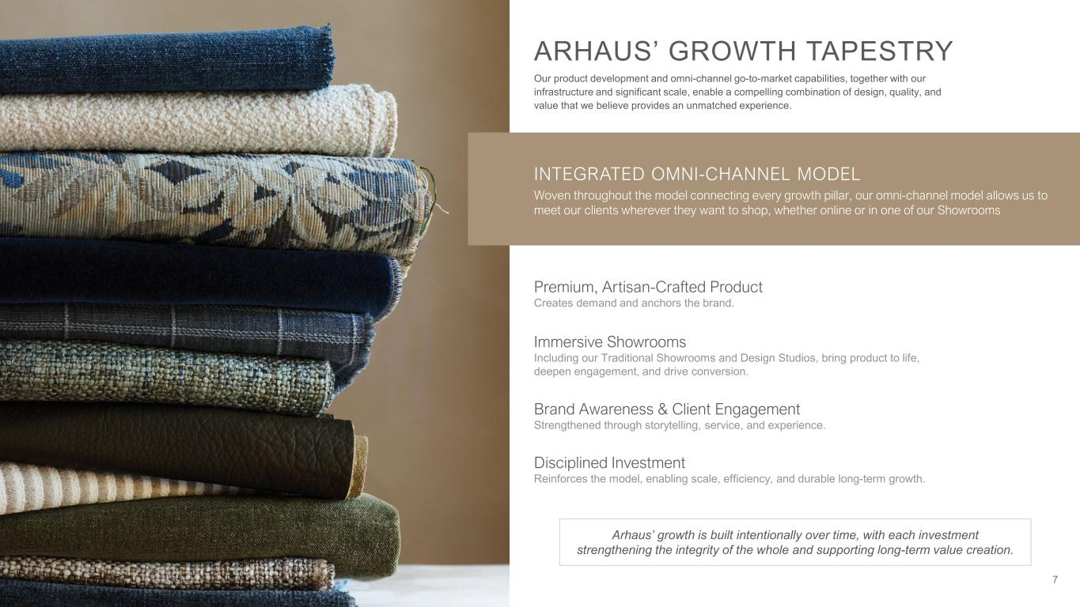
7 ARHAUS’ GROWTH TAPESTRY Our product development and omni-channel go-to-market capabilities, together with our infrastructure and significant scale, enable a compelling combination of design, quality, and value that we believe provides an unmatched experience. Arhaus’ growth is built intentionally over time, with each investment strengthening the integrity of the whole and supporting long-term value creation. INTEGRATED OMNI-CHANNEL MODEL Woven throughout the model connecting every growth pillar, our omni-channel model allows us to meet our clients wherever they want to shop, whether online or in one of our Showrooms Premium, Artisan-Crafted Product Creates demand and anchors the brand. Immersive Showrooms Including our Traditional Showrooms and Design Studios, bring product to life, deepen engagement, and drive conversion. Brand Awareness & Client Engagement Strengthened through storytelling, service, and experience. Disciplined Investment Reinforces the model, enabling scale, efficiency, and durable long-term growth.

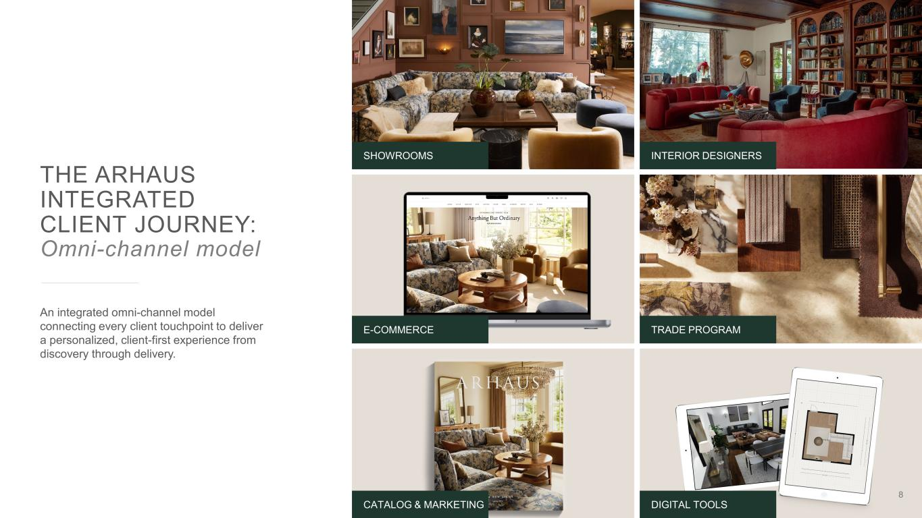
THE ARHAUS INTEGRATED CLIENT JOURNEY: Omni-channel model An integrated omni-channel model connecting every client touchpoint to deliver a personalized, client-first experience from discovery through delivery. INTERIOR DESIGNERS 8 SHOWROOMS E-COMMERCE TRADE PROGRAM CATALOG & MARKETING DIGITAL TOOLS

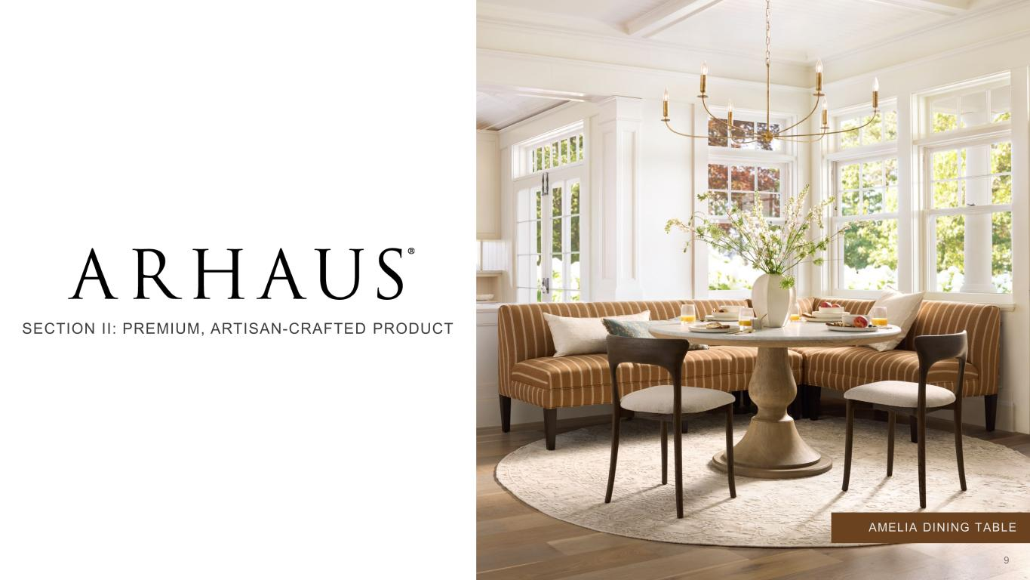
AMELIA DINING TABLE SECTION II: PREMIUM, ARTISAN-CRAFTED PRODUCT 9

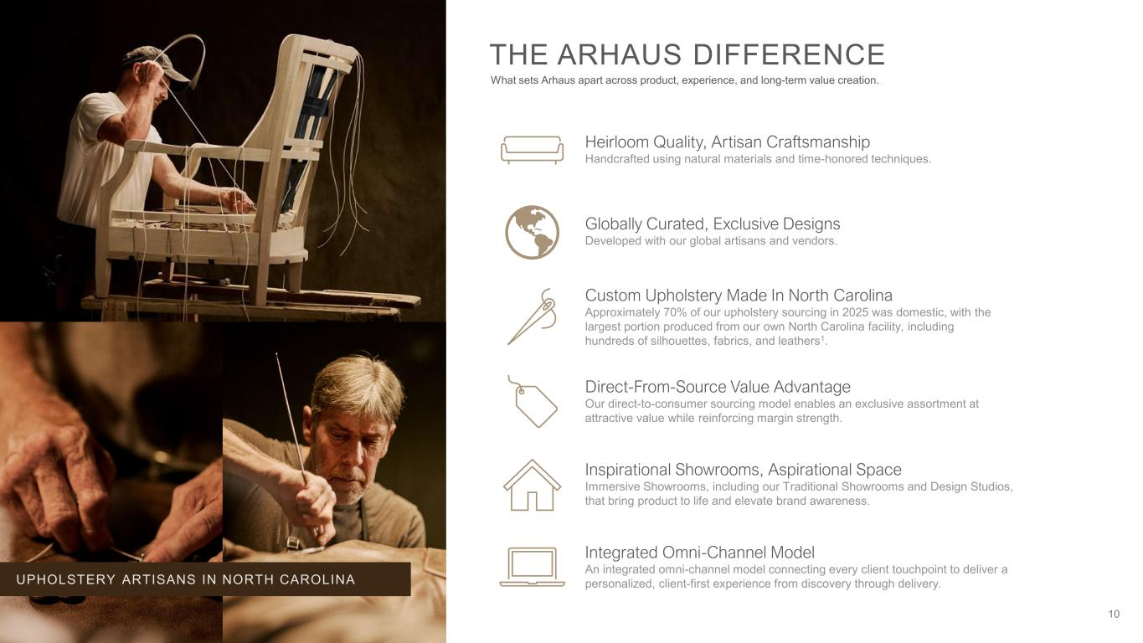
10 Heirloom Quality, Artisan Craftsmanship Handcrafted using natural materials and time-honored techniques. Custom Upholstery Made In North Carolina Approximately 70% of our upholstery sourcing in 2025 was domestic, with the largest portion produced from our own North Carolina facility, including hundreds of silhouettes, fabrics, and leathers1. Globally Curated, Exclusive Designs Developed with our global artisans and vendors. Inspirational Showrooms, Aspirational Space Immersive Showrooms, including our Traditional Showrooms and Design Studios, that bring product to life and elevate brand awareness. Integrated Omni-Channel Model An integrated omni-channel model connecting every client touchpoint to deliver a personalized, client-first experience from discovery through delivery. Direct-From-Source Value Advantage Our direct-to-consumer sourcing model enables an exclusive assortment at attractive value while reinforcing margin strength. THE ARHAUS DIFFERENCE What sets Arhaus apart across product, experience, and long-term value creation. UPHOLSTERY ARTISANS IN NORTH CAROLINA


WHAT WE SELL: Core categories that drive the business 11

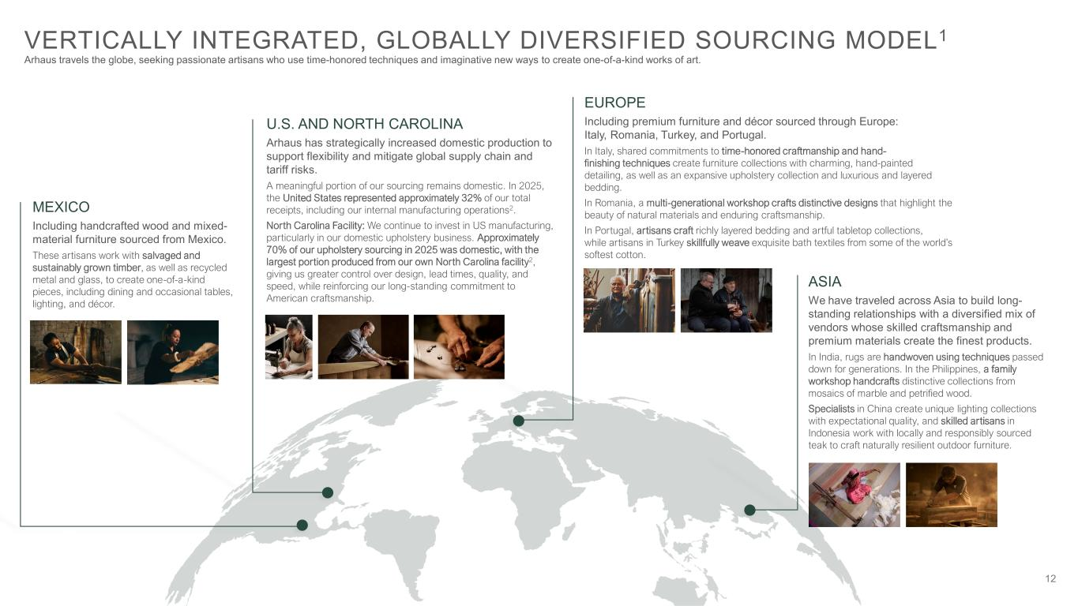
12 VERTICALLY INTEGRATED, GLOBALLY DIVERSIFIED SOURCING MODEL1 Arhaus travels the globe, seeking passionate artisans who use time-honored techniques and imaginative new ways to create one-of-a-kind works of art. MEXICO Including handcrafted wood and mixed- material furniture sourced from Mexico. These artisans work with salvaged and sustainably grown timber, as well as recycled metal and glass, to create one-of-a-kind pieces, including dining and occasional tables, lighting, and décor. U.S. AND NORTH CAROLINA Arhaus has strategically increased domestic production to support flexibility and mitigate global supply chain and tariff risks. A meaningful portion of our sourcing remains domestic. In 2025, the United States represented approximately 32% of our total receipts, including our internal manufacturing operations2. North Carolina Facility: We continue to invest in US manufacturing, particularly in our domestic upholstery business. Approximately 70% of our upholstery sourcing in 2025 was domestic, with the largest portion produced from our own North Carolina facility2, giving us greater control over design, lead times, quality, and speed, while reinforcing our long-standing commitment to American craftsmanship. ASIA We have traveled across Asia to build long- standing relationships with a diversified mix of vendors whose skilled craftsmanship and premium materials create the finest products. In India, rugs are handwoven using techniques passed down for generations. In the Philippines, a family workshop handcrafts distinctive collections from mosaics of marble and petrified wood. Specialists in China create unique lighting collections with expectational quality, and skilled artisans in Indonesia work with locally and responsibly sourced teak to craft naturally resilient outdoor furniture. EUROPE Including premium furniture and décor sourced through Europe: Italy, Romania, Turkey, and Portugal. In Italy, shared commitments to time-honored craftmanship and hand- finishing techniques create furniture collections with charming, hand-painted detailing, as well as an expansive upholstery collection and luxurious and layered bedding. In Romania, a multi-generational workshop crafts distinctive designs that highlight the beauty of natural materials and enduring craftsmanship. In Portugal, artisans craft richly layered bedding and artful tabletop collections, while artisans in Turkey skillfully weave exquisite bath textiles from some of the world’s softest cotton.

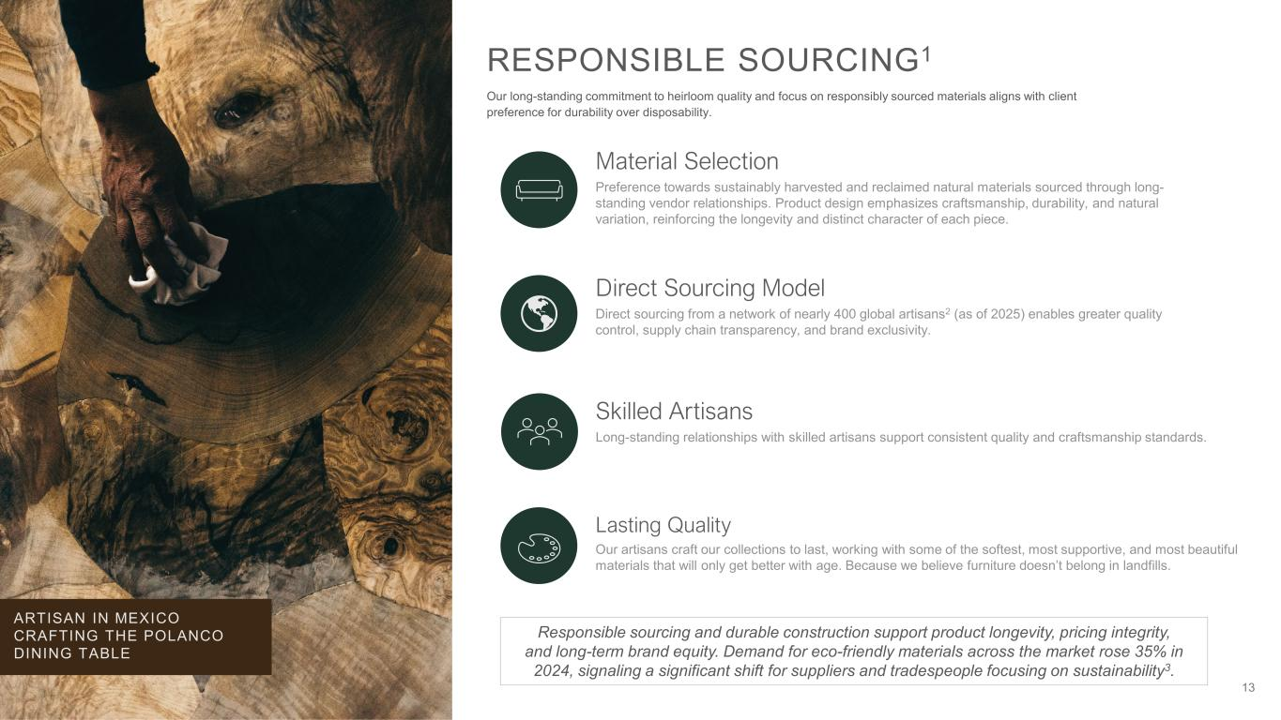
13 RESPONSIBLE SOURCING1 Our long-standing commitment to heirloom quality and focus on responsibly sourced materials aligns with client preference for durability over disposability. Material Selection Preference towards sustainably harvested and reclaimed natural materials sourced through long- standing vendor relationships. Product design emphasizes craftsmanship, durability, and natural variation, reinforcing the longevity and distinct character of each piece. Direct Sourcing Model Direct sourcing from a network of nearly 400 global artisans2 (as of 2025) enables greater quality control, supply chain transparency, and brand exclusivity. Skilled Artisans Long-standing relationships with skilled artisans support consistent quality and craftsmanship standards. Responsible sourcing and durable construction support product longevity, pricing integrity, and long-term brand equity. Demand for eco-friendly materials across the market rose 35% in 2024, signaling a significant shift for suppliers and tradespeople focusing on sustainability3. ARTISAN IN MEXICO CRAFTING THE POLANCO DINING TABLE Lasting Quality Our artisans craft our collections to last, working with some of the softest, most supportive, and most beautiful materials that will only get better with age. Because we believe furniture doesn’t belong in landfills.


14 FURNISHING A BETTER WORLD We are focused on doing what’s right—for the environment, for our communities near and far, and for each other1. RAINFOREST IN EAST KALIMANTAN, BORNEO Protecting the Rainforest Arhaus’ work with The Nature Conservancy and its Indonesian affiliate, YKAN, includes helping to preserve hundreds of acres of rainforest in East Kalimantan, Borneo, protecting biodiversity and supporting one of the world’s most important carbon-absorbing ecosystems. Building Homes We support Habitat for Humanity in its mission to build strength, stability, and self-reliance through shelter in our communities, and we proudly donate furniture and décor to Habitat for Humanity ReStore locations across the country. Supporting Smiles Through Arhaus’ long-standing partnership with Global Dental Relief, free dental care and education are provided to children in underserved communities across Nepal, India, Kenya, and Guatemala, supporting long-term oral health. Fostering Futures Built in partnership with The Small World, The Friends of Arhaus Children’s Home is the first project of its kind in the Solukhumbu district of Nepal—providing more than 80 boys and girls a safe and loving place to live, learn, and build their futures.

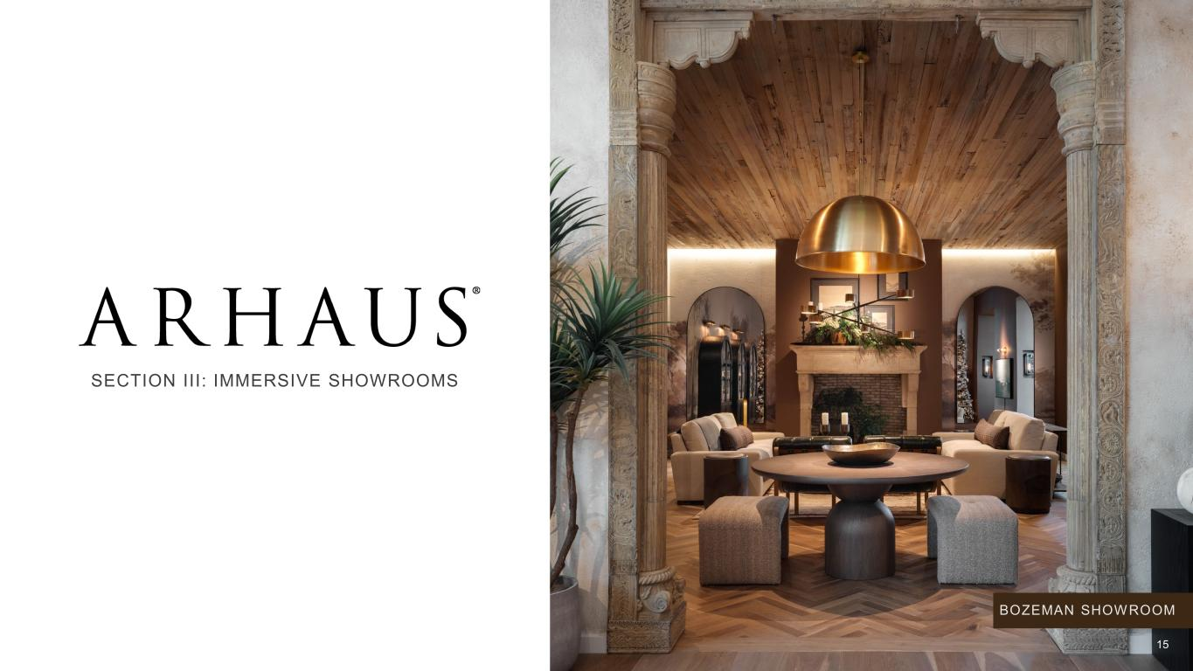
SECTION III: IMMERSIVE SHOWROOMS BOZEMAN SHOWROOM 15

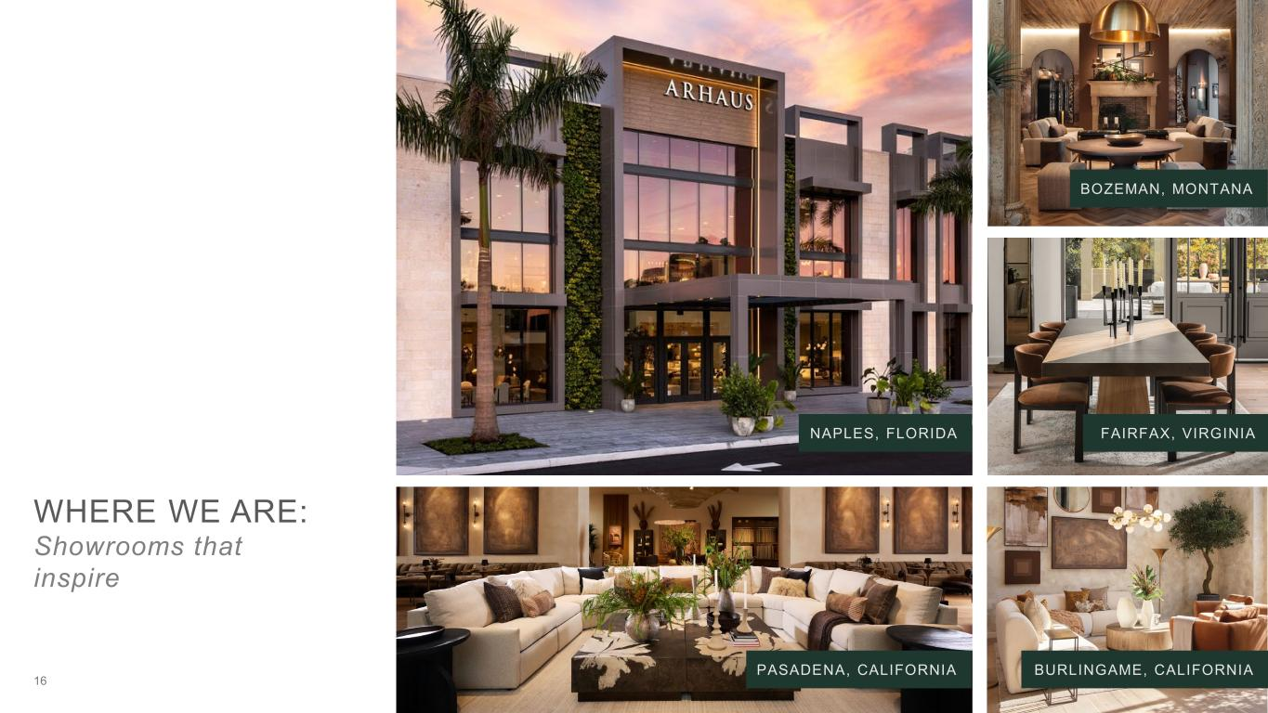
WHERE WE ARE: Showrooms that inspire BOZEMAN, MONTANA 16 FAIRFAX, VIRGINIA BURLINGAME, CALIFORNIA NAPLES, FLORIDA PASADENA, CALIFORNIA

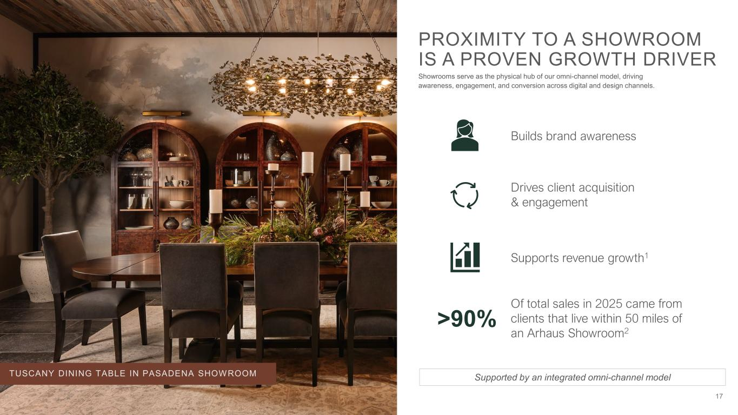
PROXIMITY TO A SHOWROOM IS A PROVEN GROWTH DRIVER Showrooms serve as the physical hub of our omni-channel model, driving awareness, engagement, and conversion across digital and design channels. Supports revenue growth1 Builds brand awareness Drives client acquisition & engagement Supported by an integrated omni-channel modelTUSCANY DINING TABLE IN PASADENA SHOWROOM >90% Of total sales in 2025 came from clients that live within 50 miles of an Arhaus Showroom2 17

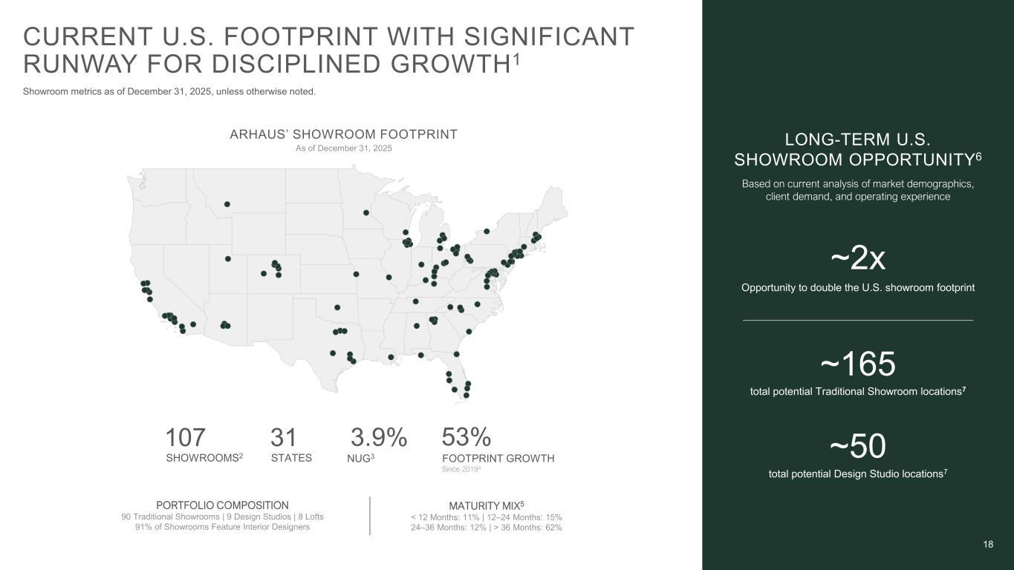
18 CURRENT U.S. FOOTPRINT WITH SIGNIFICANT RUNWAY FOR DISCIPLINED GROWTH1 Showroom metrics as of December 31, 2025, unless otherwise noted. LONG-TERM U.S. SHOWROOM OPPORTUNITY6 ~50 total potential Design Studio locations7 ~2x Opportunity to double the U.S. showroom footprint ~165 total potential Traditional Showroom locations7 ARHAUS’ SHOWROOM FOOTPRINT PORTFOLIO COMPOSITION 90 Traditional Showrooms | 9 Design Studios | 8 Lofts 91% of Showrooms Feature Interior Designers MATURITY MIX5 < 12 Months: 11% | 12–24 Months: 15% 24–36 Months: 12% | > 36 Months: 62% 107 SHOWROOMS2 31 STATES 3.9% NUG3 53% FOOTPRINT GROWTH Since 20194 Based on current analysis of market demographics, client demand, and operating experience As of December 31, 2025

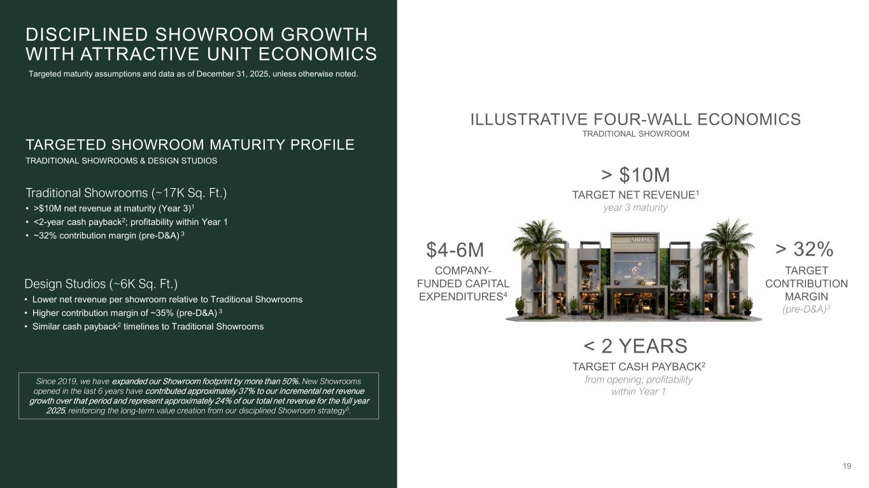
19 DISCIPLINED SHOWROOM GROWTH WITH ATTRACTIVE UNIT ECONOMICS Targeted maturity assumptions and data as of December 31, 2025, unless otherwise noted. ILLUSTRATIVE FOUR-WALL ECONOMICS TRADITIONAL SHOWROOM > $10M TARGET NET REVENUE1 year 3 maturity < 2 YEARS TARGET CASH PAYBACK2 from opening; profitability within Year 1 $4-6M COMPANY- FUNDED CAPITAL EXPENDITURES4 > 32% TARGET CONTRIBUTION MARGIN (pre-D&A)3 TARGETED SHOWROOM MATURITY PROFILE TRADITIONAL SHOWROOMS & DESIGN STUDIOS Traditional Showrooms (~17K Sq. Ft.) • >$10M net revenue at maturity (Year 3)1 • <2-year cash payback2; profitability within Year 1 • ~32% contribution margin (pre-D&A) 3 Design Studios (~6K Sq. Ft.) • Lower net revenue per showroom relative to Traditional Showrooms • Higher contribution margin of ~35% (pre-D&A) 3 • Similar cash payback2 timelines to Traditional Showrooms Since 2019, we have expanded our Showroom footprint by more than 50%. New Showrooms opened in the last 6 years have contributed approximately 37% to our incremental net revenue growth over that period and represent approximately 24% of our total net revenue for the full year 2025, reinforcing the long-term value creation from our disciplined Showroom strategy5.

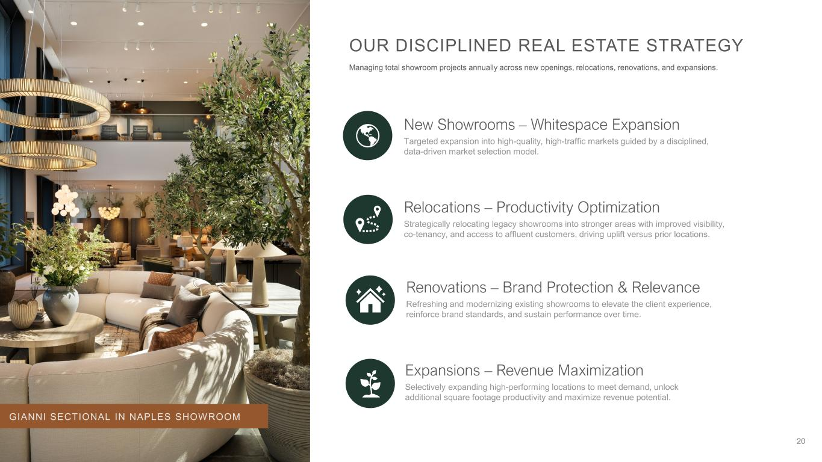
20 OUR DISCIPLINED REAL ESTATE STRATEGY Managing total showroom projects annually across new openings, relocations, renovations, and expansions. New Showrooms – Whitespace Expansion Targeted expansion into high-quality, high-traffic markets guided by a disciplined, data-driven market selection model. Relocations – Productivity Optimization Strategically relocating legacy showrooms into stronger areas with improved visibility, co-tenancy, and access to affluent customers, driving uplift versus prior locations. Renovations – Brand Protection & Relevance Refreshing and modernizing existing showrooms to elevate the client experience, reinforce brand standards, and sustain performance over time. Expansions – Revenue Maximization Selectively expanding high-performing locations to meet demand, unlock additional square footage productivity and maximize revenue potential. GIANNI SECTIONAL IN NAPLES SHOWROOM

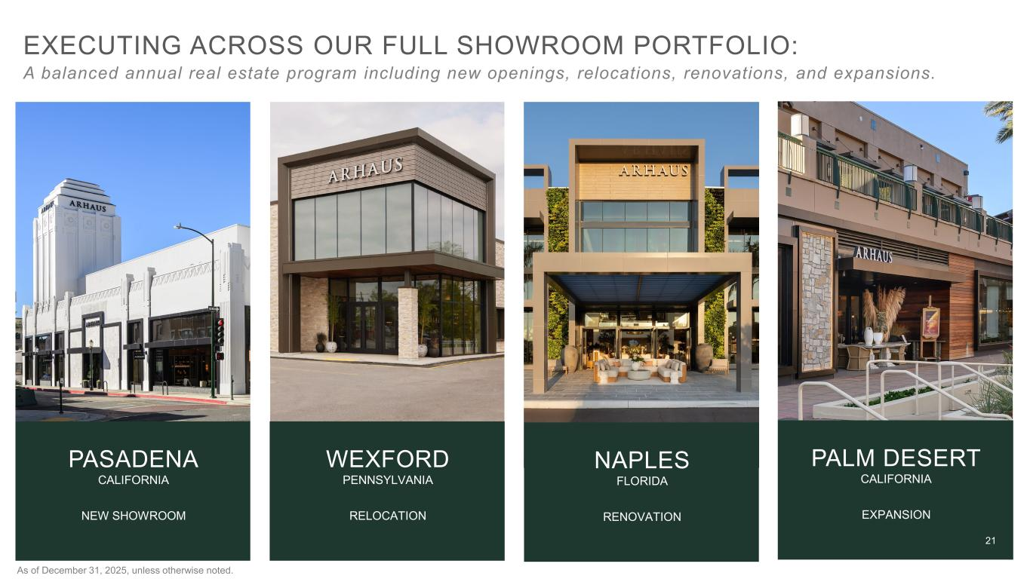
21 EXECUTING ACROSS OUR FULL SHOWROOM PORTFOLIO: A balanced annual real estate program including new openings, relocations, renovations, and expansions. PASADENA CALIFORNIA NEW SHOWROOM NAPLES FLORIDA RENOVATION PALM DESERT CALIFORNIA EXPANSION WEXFORD PENNSYLVANIA RELOCATION 21 As of December 31, 2025, unless otherwise noted.


SECTION IV: BRAND AWARENESS & CLIENT ENGAGEMENT SAVANNAH CHAIR 22

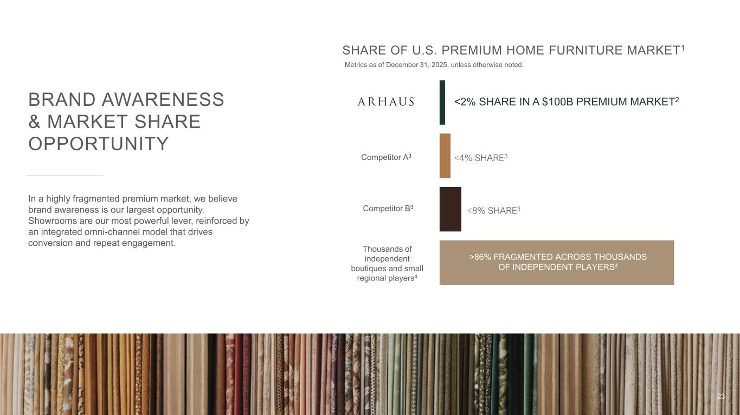
BRAND AWARENESS & MARKET SHARE OPPORTUNITY In a highly fragmented premium market, we believe brand awareness is our largest opportunity. Showrooms are our most powerful lever, reinforced by an integrated omni-channel model that drives conversion and repeat engagement. SHARE OF U.S. PREMIUM HOME FURNITURE MARKET1 <2% SHARE IN A $100B PREMIUM MARKET2 Thousands of independent boutiques and small regional players4 <4% SHARE3 <8% SHARE3 >86% FRAGMENTED ACROSS THOUSANDS OF INDEPENDENT PLAYERS4 Competitor A3 Competitor B3 Metrics as of December 31, 2025, unless otherwise noted. 23

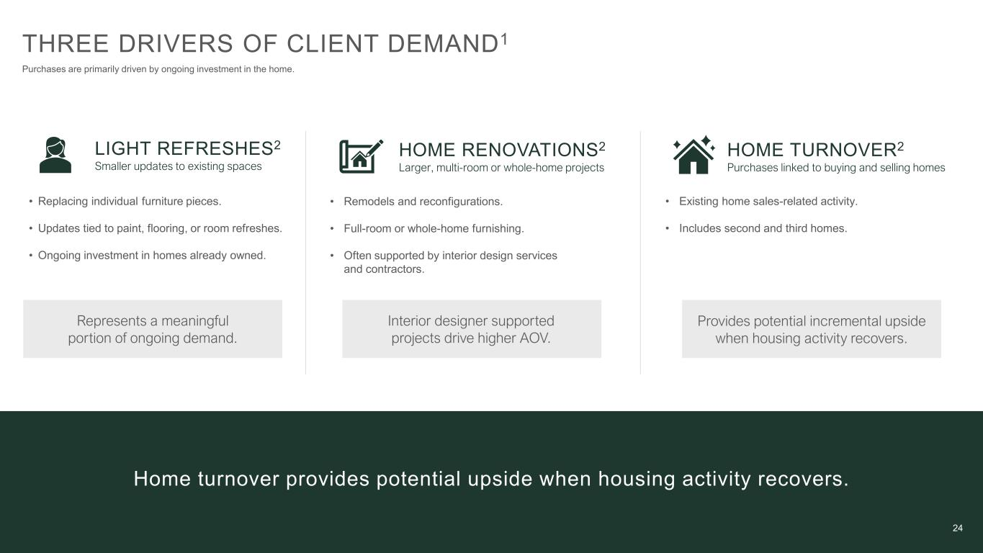
24 THREE DRIVERS OF CLIENT DEMAND1 Purchases are primarily driven by ongoing investment in the home. 24 LIGHT REFRESHES2 Smaller updates to existing spaces • Replacing individual furniture pieces. • Updates tied to paint, flooring, or room refreshes. • Ongoing investment in homes already owned. HOME RENOVATIONS2 Larger, multi-room or whole-home projects HOME TURNOVER2 Purchases linked to buying and selling homes Represents a meaningful portion of ongoing demand. Interior designer supported projects drive higher AOV. Provides potential incremental upside when housing activity recovers. • Remodels and reconfigurations. • Full-room or whole-home furnishing. • Often supported by interior design services and contractors. • Existing home sales-related activity. • Includes second and third homes. Home turnover provides potential upside when housing activity recovers.

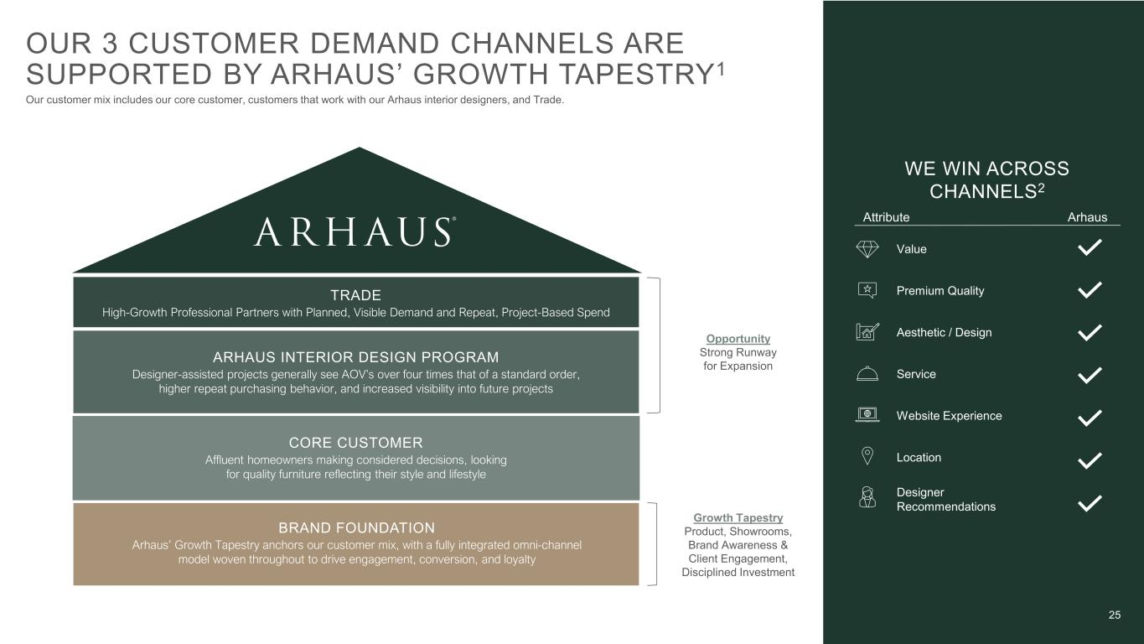
25 CORE CUSTOMER Affluent homeowners making considered decisions, looking for quality furniture reflecting their style and lifestyle ARHAUS INTERIOR DESIGN PROGRAM Designer-assisted projects generally see AOV’s over four times that of a standard order, higher repeat purchasing behavior, and increased visibility into future projects TRADE High-Growth Professional Partners with Planned, Visible Demand and Repeat, Project-Based Spend BRAND FOUNDATION Arhaus’ Growth Tapestry anchors our customer mix, with a fully integrated omni-channel model woven throughout to drive engagement, conversion, and loyalty WE WIN ACROSS CHANNELS2 Aesthetic / Design Premium Quality Value Service Website Experience Location Designer Recommendations Attribute Arhaus Opportunity Strong Runway for Expansion OUR 3 CUSTOMER DEMAND CHANNELS ARE SUPPORTED BY ARHAUS’ GROWTH TAPESTRY1 Our customer mix includes our core customer, customers that work with our Arhaus interior designers, and Trade. Growth Tapestry Product, Showrooms, Brand Awareness & Client Engagement, Disciplined Investment

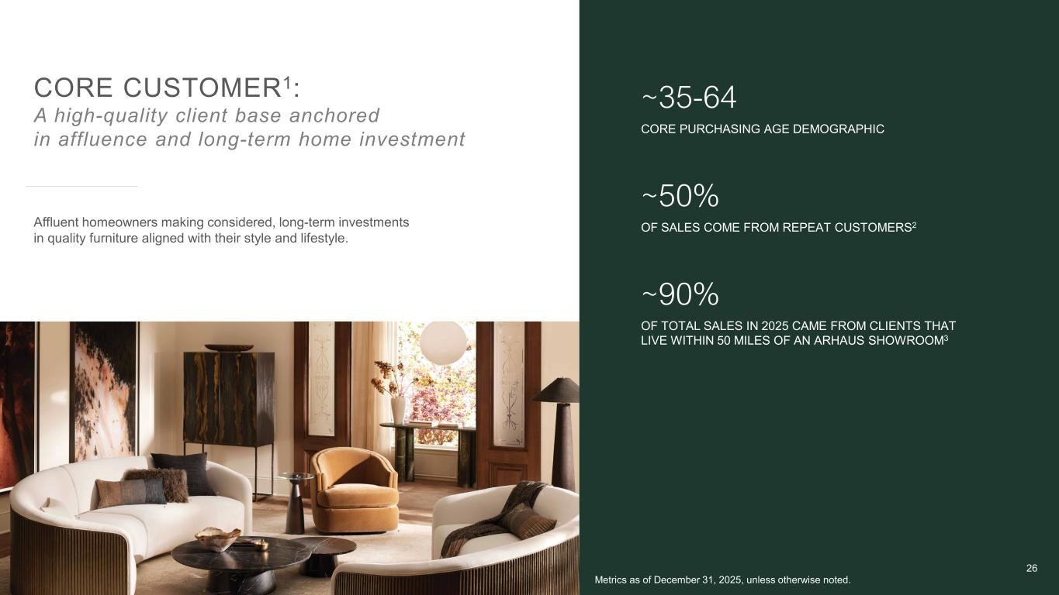
CORE CUSTOMER1: A high-quality client base anchored in affluence and long-term home investment ~35-64 CORE PURCHASING AGE DEMOGRAPHIC ~50% OF SALES COME FROM REPEAT CUSTOMERS2 ~90% OF TOTAL SALES IN 2025 CAME FROM CLIENTS THAT LIVE WITHIN 50 MILES OF AN ARHAUS SHOWROOM3 Affluent homeowners making considered, long-term investments in quality furniture aligned with their style and lifestyle. Metrics as of December 31, 2025, unless otherwise noted. 26

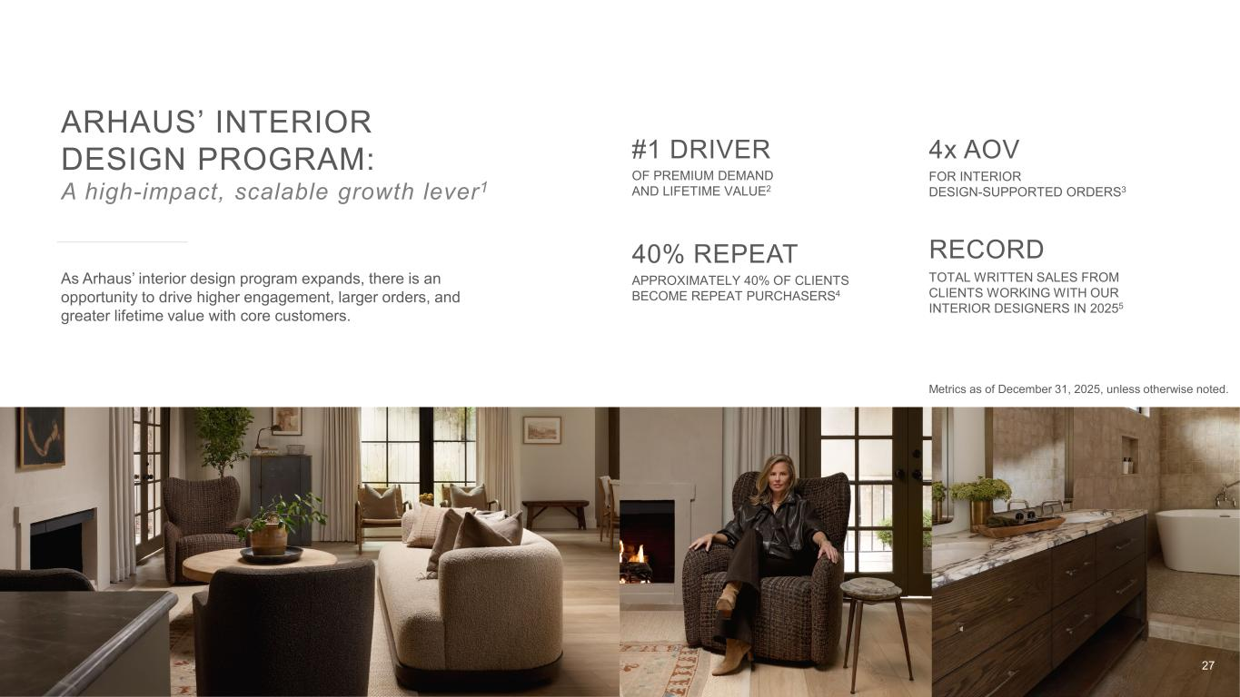
40% REPEAT APPROXIMATELY 40% OF CLIENTS BECOME REPEAT PURCHASERS4 4x AOV FOR INTERIOR DESIGN-SUPPORTED ORDERS3 RECORD TOTAL WRITTEN SALES FROM CLIENTS WORKING WITH OUR INTERIOR DESIGNERS IN 20255 #1 DRIVER OF PREMIUM DEMAND AND LIFETIME VALUE2 ARHAUS’ INTERIOR DESIGN PROGRAM: A high-impact, scalable growth lever1 As Arhaus’ interior design program expands, there is an opportunity to drive higher engagement, larger orders, and greater lifetime value with core customers. Metrics as of December 31, 2025, unless otherwise noted. 27


Total Market Source: IBISWorld, Interior Designers in the US, July 2025. ~185,000 DESIGNERS IN THE U.S. INFLUENCING PREMIUM RESIDENTIAL FURNISHING PURCHASES1 ~4.2% 5-YR CAGR REVENUE GROWTH OF THE U.S. INTERIOR DESIGN SERVICES MARKET 2020-20251 63% of REVENUE FROM THE U.S. INTERIOR DESIGN INDUSTRY IS TIED TO INDIVIDUALS AND HOUSEHOLDS1 ~$27 BILLION U.S. INTERIOR DESIGN SERVICES MARKET1 28 TRADE A significant market opportunity The U.S. has ~185,000 interior designers1, operating across a highly fragmented market and influencing a meaningful share of premium residential furnishing spend.


• One-Stop Solution for Whole-Home Projects • White-Glove, VIP Service Model • Simplified Logistics, Storage, and Delivery • Premium, Artisan-Crafted Assortment • Customization and Design Flexibility • Reliable Execution and Ease of Purchase WHY TRADE DESIGNERS CONSISTENTLY PARTNER WITH ARHAUS Designers rely on Arhaus as a trusted execution partner for complex projects, allowing them to stay focused on client relationships and outcomes while we manage the rest. 29 ARHAUS WHITE-GLOVE DELIVERY

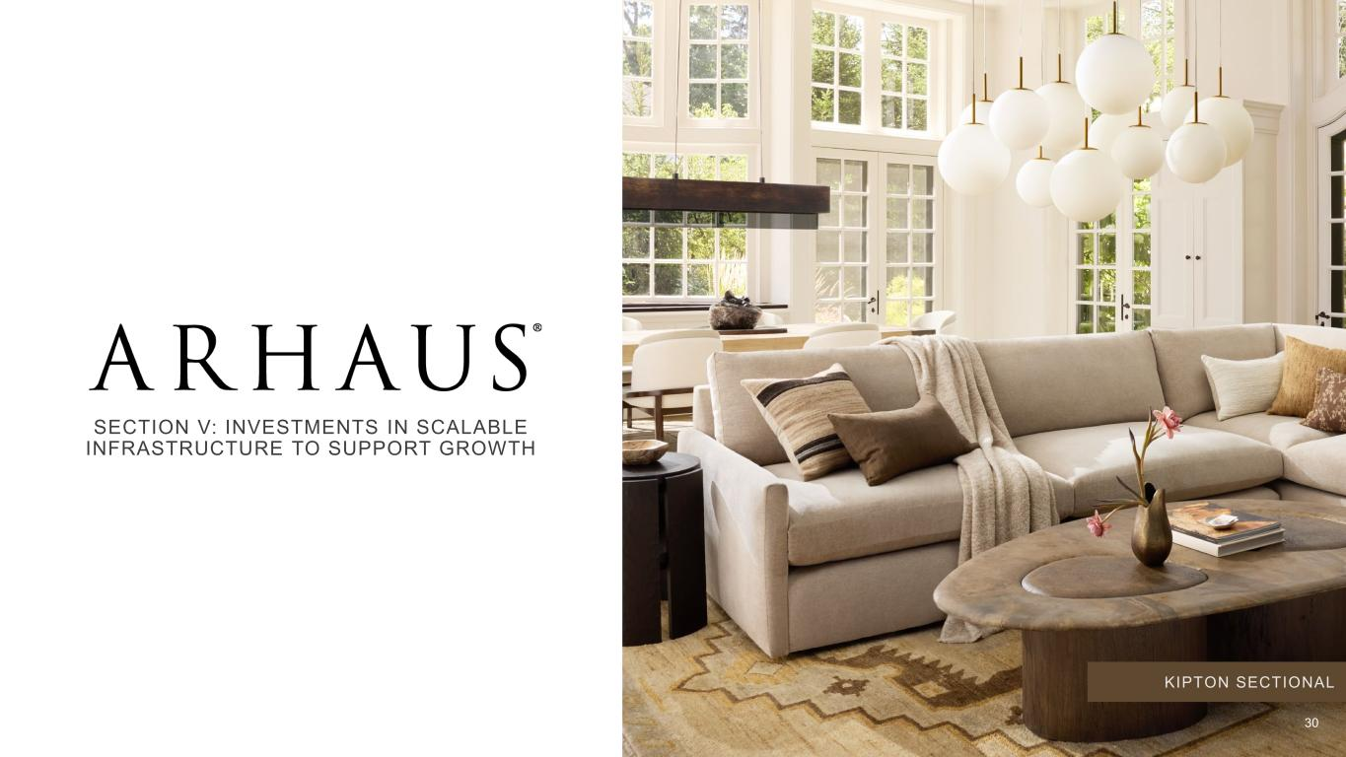
SECTION V: INVESTMENTS IN SCALABLE INFRASTRUCTURE TO SUPPORT GROWTH KIPTON SECTIONAL 30

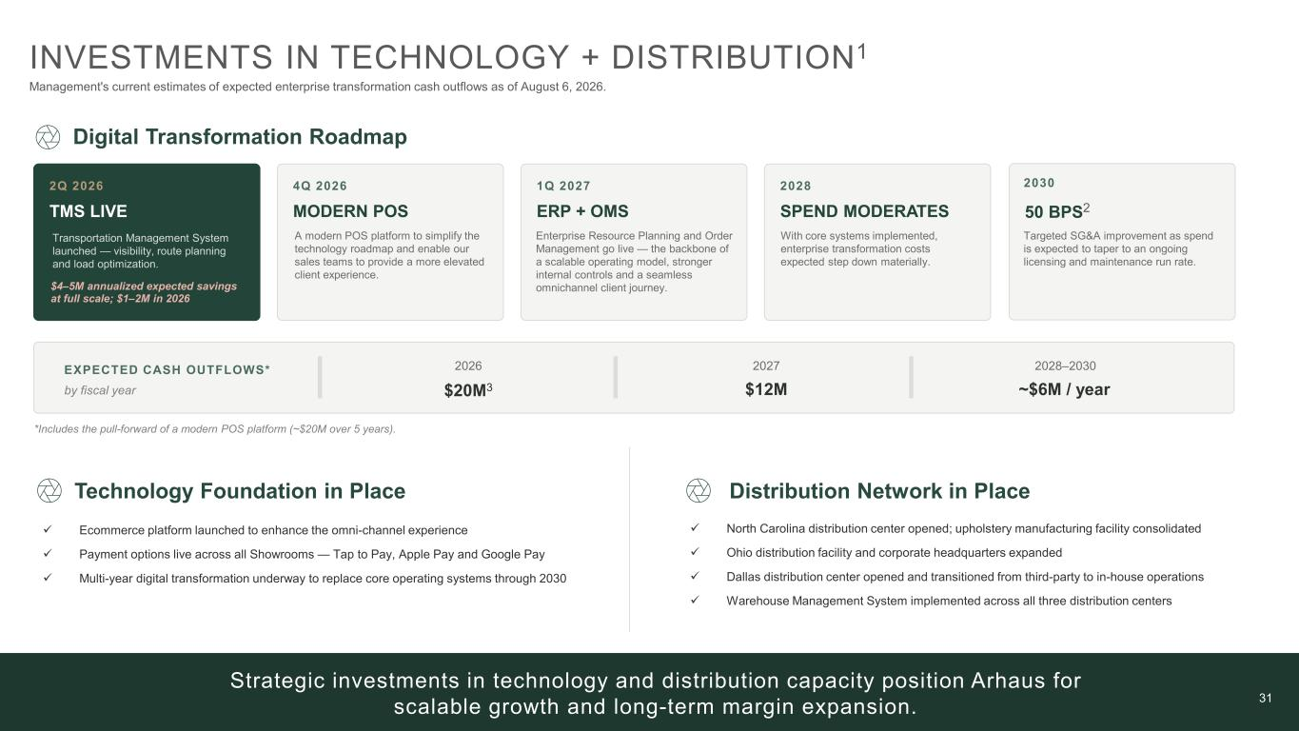
31 Strategic investments in technology and distribution capacity position Arhaus for scalable growth and long-term margin expansion. INVESTMENTS IN TECHNOLOGY + DISTRIBUTION1 Management's current estimates of expected enterprise transformation cash outflows as of August 6, 2026. Digital Transformation Roadmap 2Q 2026 TMS LIVE 4Q 2026 MODERN POS 1Q 2027 ERP + OMS 2028 SPEND MODERATES 2030 50 BPS2 EXPECTED CASH OUTFLOWS* by fiscal year 2026 $20M3 2027 $12M 2028–2030 ~$6M / year Technology Foundation in Place ✓ Ecommerce platform launched to enhance the omni-channel experience ✓ Payment options live across all Showrooms — Tap to Pay, Apple Pay and Google Pay ✓ Multi-year digital transformation underway to replace core operating systems through 2030 Distribution Network in Place ✓ North Carolina distribution center opened; upholstery manufacturing facility consolidated ✓ Ohio distribution facility and corporate headquarters expanded ✓ Dallas distribution center opened and transitioned from third-party to in-house operations ✓ Warehouse Management System implemented across all three distribution centers $4–5M annualized expected savings at full scale; $1–2M in 2026 Transportation Management System launched — visibility, route planning and load optimization. A modern POS platform to simplify the technology roadmap and enable our sales teams to provide a more elevated client experience. Enterprise Resource Planning and Order Management go live — the backbone of a scalable operating model, stronger internal controls and a seamless omnichannel client journey. With core systems implemented, enterprise transformation costs expected step down materially. Targeted SG&A improvement as spend is expected to taper to an ongoing licensing and maintenance run rate. *Includes the pull-forward of a modern POS platform (~$20M over 5 years).

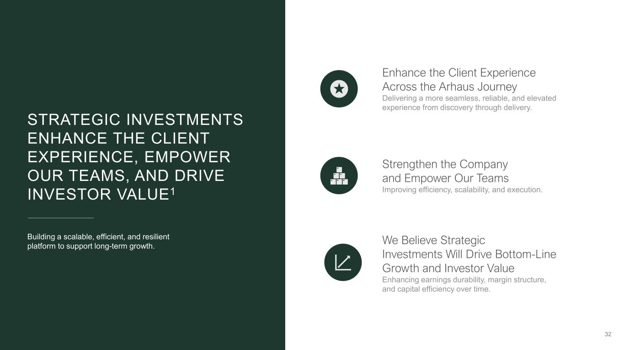
32 Enhance the Client Experience Across the Arhaus Journey Delivering a more seamless, reliable, and elevated experience from discovery through delivery. Strengthen the Company and Empower Our Teams Improving efficiency, scalability, and execution. We Believe Strategic Investments Will Drive Bottom-Line Growth and Investor Value Enhancing earnings durability, margin structure, and capital efficiency over time. STRATEGIC INVESTMENTS ENHANCE THE CLIENT EXPERIENCE, EMPOWER OUR TEAMS, AND DRIVE INVESTOR VALUE1 Building a scalable, efficient, and resilient platform to support long-term growth.


SECTION VI: QUARTERLY PERFORMANCE UPDATE CHELSEA WASHSTAND 33

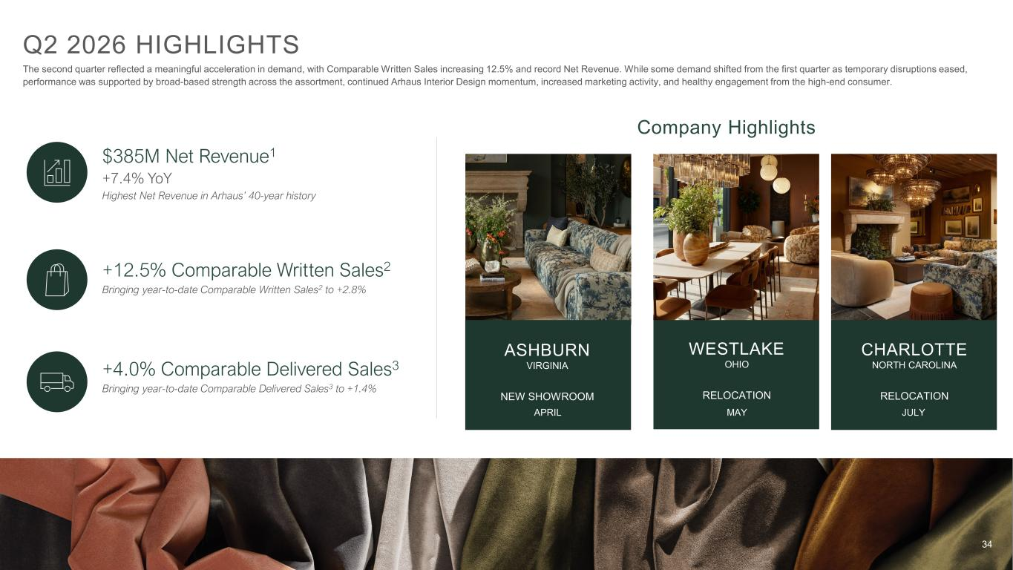
34 Q2 2026 HIGHLIGHTS $385M Net Revenue1 +7.4% YoY Highest Net Revenue in Arhaus’ 40-year history +12.5% Comparable Written Sales2 Bringing year-to-date Comparable Written Sales2 to +2.8% +4.0% Comparable Delivered Sales3 Bringing year-to-date Comparable Delivered Sales3 to +1.4% The second quarter reflected a meaningful acceleration in demand, with Comparable Written Sales increasing 12.5% and record Net Revenue. While some demand shifted from the first quarter as temporary disruptions eased, performance was supported by broad-based strength across the assortment, continued Arhaus Interior Design momentum, increased marketing activity, and healthy engagement from the high-end consumer. WESTLAKE OHIO RELOCATION Company Highlights ASHBURN VIRGINIA NEW SHOWROOM CHARLOTTE NORTH CAROLINA RELOCATION APRIL MAY JULY

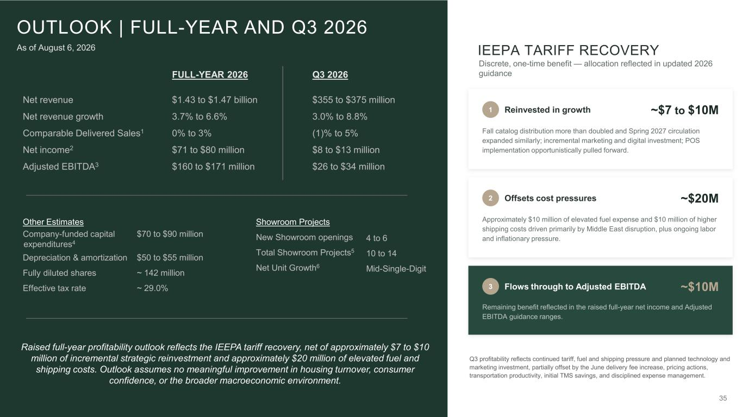
35 FULL-YEAR 2026 Q3 2026 Net revenue Net revenue growth Comparable Delivered Sales1 Net income2 Adjusted EBITDA3 $1.43 to $1.47 billion 3.7% to 6.6% 0% to 3% $71 to $80 million $160 to $171 million $355 to $375 million 3.0% to 8.8% (1)% to 5% $8 to $13 million $26 to $34 million OUTLOOK | FULL-YEAR AND Q3 2026 $70 to $90 million $50 to $55 million ~ 142 million ~ 29.0% 4 to 6 10 to 14 Mid-Single-Digit Other Estimates Company-funded capital expenditures4 Depreciation & amortization Fully diluted shares Effective tax rate Showroom Projects New Showroom openings Total Showroom Projects5 Net Unit Growth6 As of August 6, 2026 Raised full-year profitability outlook reflects the IEEPA tariff recovery, net of approximately $7 to $10 million of incremental strategic reinvestment and approximately $20 million of elevated fuel and shipping costs. Outlook assumes no meaningful improvement in housing turnover, consumer confidence, or the broader macroeconomic environment. IEEPA TARIFF RECOVERY Discrete, one-time benefit — allocation reflected in updated 2026 guidance 1 Reinvested in growth ~$7 to $10M Fall catalog distribution more than doubled and Spring 2027 circulation expanded similarly; incremental marketing and digital investment; POS implementation opportunistically pulled forward. 2 Offsets cost pressures ~$20M Approximately $10 million of elevated fuel expense and $10 million of higher shipping costs driven primarily by Middle East disruption, plus ongoing labor and inflationary pressure. 3 Flows through to Adjusted EBITDA ~$10M Remaining benefit reflected in the raised full-year net income and Adjusted EBITDA guidance ranges. Q3 profitability reflects continued tariff, fuel and shipping pressure and planned technology and marketing investment, partially offset by the June delivery fee increase, pricing actions, transportation productivity, initial TMS savings, and disciplined expense management.

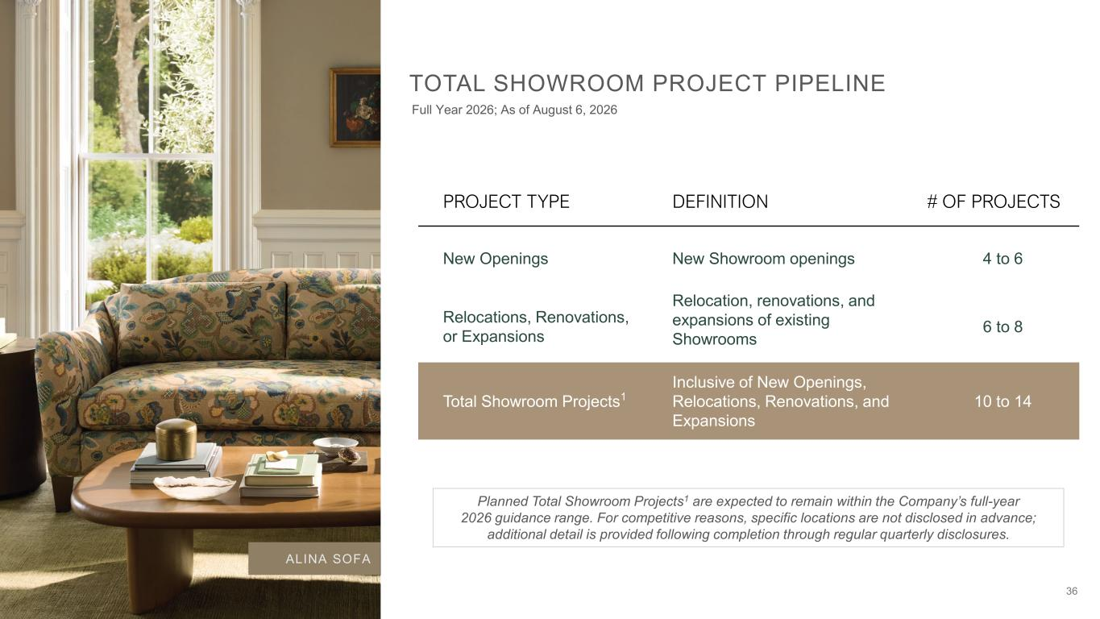
36 PROJECT TYPE DEFINITION # OF PROJECTS New Openings New Showroom openings 4 to 6 Relocations, Renovations, or Expansions Relocation, renovations, and expansions of existing Showrooms 6 to 8 Total Showroom Projects1 Inclusive of New Openings, Relocations, Renovations, and Expansions 10 to 14 TOTAL SHOWROOM PROJECT PIPELINE Planned Total Showroom Projects1 are expected to remain within the Company’s full-year 2026 guidance range. For competitive reasons, specific locations are not disclosed in advance; additional detail is provided following completion through regular quarterly disclosures. ALINA SOFA Full Year 2026; As of August 6, 2026

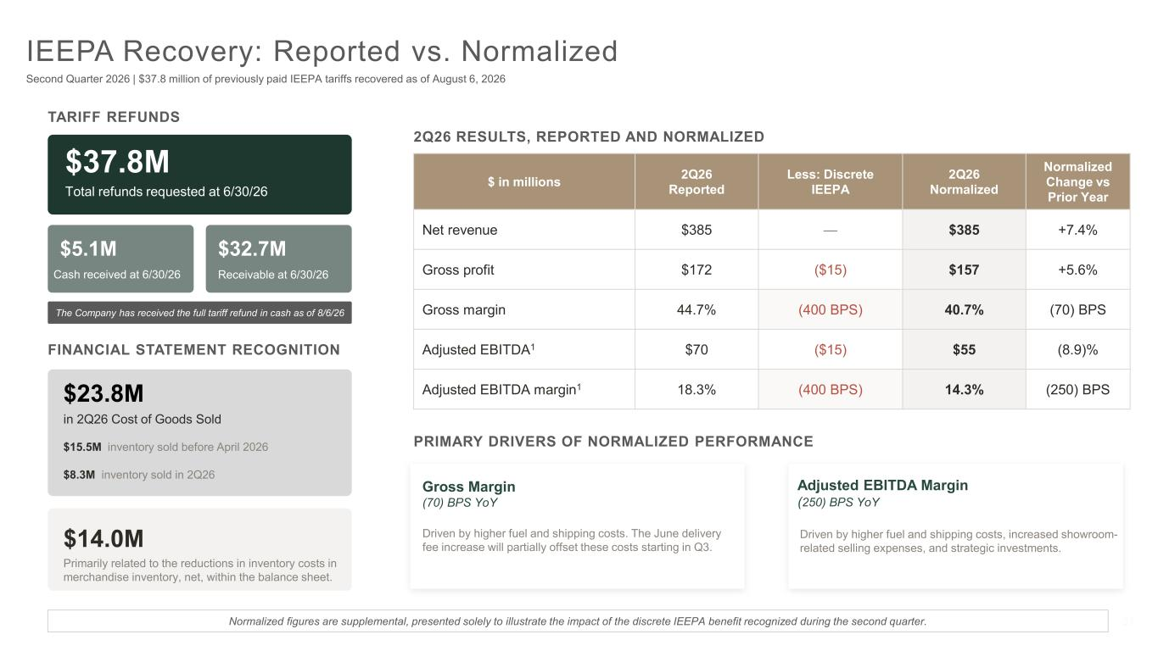
37 IEEPA Recovery: Reported vs. Normalized Second Quarter 2026 | $37.8 million of previously paid IEEPA tariffs recovered as of August 6, 2026 TARIFF REFUNDS $37.8M Total refunds requested at 6/30/26 $5.1M Cash received at 6/30/26 $32.7M Receivable at 6/30/26 FINANCIAL STATEMENT RECOGNITION $23.8M in 2Q26 Cost of Goods Sold $15.5M inventory sold before April 2026 $8.3M inventory sold in 2Q26 $14.0M Primarily related to the reductions in inventory costs in merchandise inventory, net, within the balance sheet. 2Q26 RESULTS, REPORTED AND NORMALIZED $ in millions 2Q26 Reported Less: Discrete IEEPA 2Q26 Normalized Normalized Change vs Prior Year Net revenue $385 — $385 +7.4% Gross profit $172 ($15) $157 +5.6% Gross margin 44.7% (400 BPS) 40.7% (70) BPS Adjusted EBITDA1 $70 ($15) $55 (8.9)% Adjusted EBITDA margin1 18.3% (400 BPS) 14.3% (250) BPS Normalized figures are supplemental, presented solely to illustrate the impact of the discrete IEEPA benefit recognized during the second quarter. Gross Margin (70) BPS YoY Driven by higher fuel and shipping costs. The June delivery fee increase will partially offset these costs starting in Q3. Adjusted EBITDA Margin (250) BPS YoY Driven by higher fuel and shipping costs, increased showroom- related selling expenses, and strategic investments. PRIMARY DRIVERS OF NORMALIZED PERFORMANCE The Company has received the full tariff refund in cash as of 8/6/26

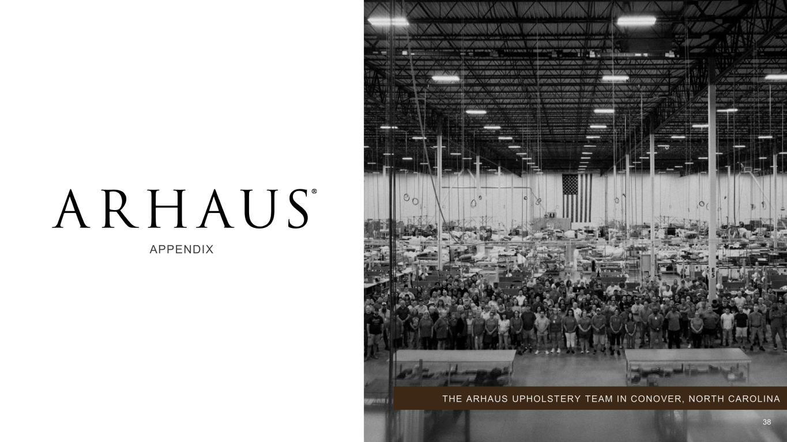
APPENDIX THE ARHAUS UPHOLSTERY TEAM IN CONOVER, NORTH CAROLINA 38

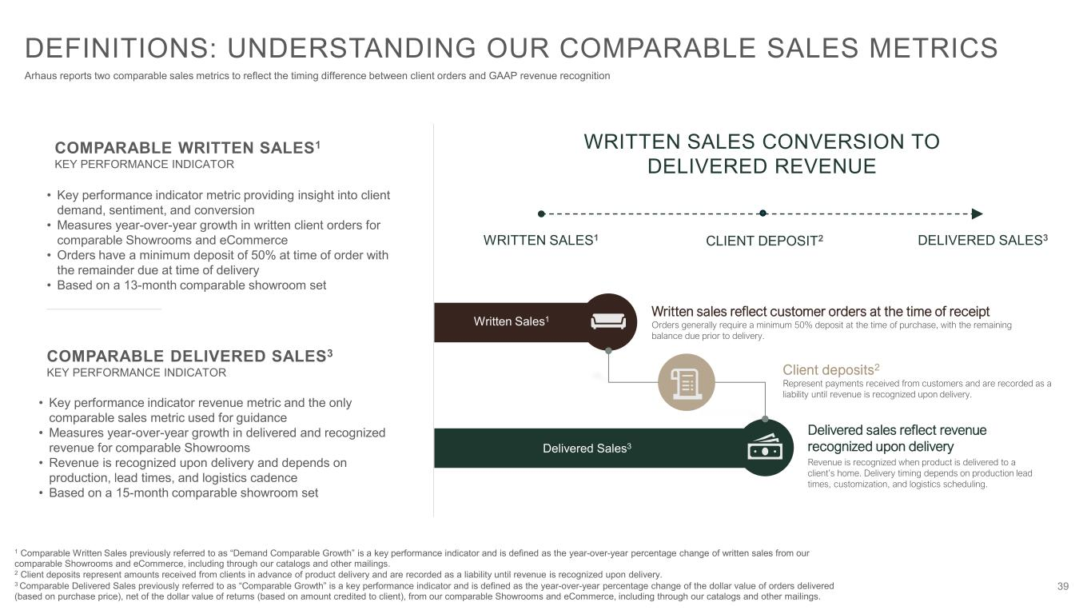
39 COMPARABLE WRITTEN SALES1 KEY PERFORMANCE INDICATOR COMPARABLE DELIVERED SALES3 KEY PERFORMANCE INDICATOR • Key performance indicator metric providing insight into client demand, sentiment, and conversion • Measures year-over-year growth in written client orders for comparable Showrooms and eCommerce • Orders have a minimum deposit of 50% at time of order with the remainder due at time of delivery • Based on a 13-month comparable showroom set • Key performance indicator revenue metric and the only comparable sales metric used for guidance • Measures year-over-year growth in delivered and recognized revenue for comparable Showrooms • Revenue is recognized upon delivery and depends on production, lead times, and logistics cadence • Based on a 15-month comparable showroom set WRITTEN SALES CONVERSION TO DELIVERED REVENUE WRITTEN SALES1 DELIVERED SALES3 Written sales reflect customer orders at the time of receipt Orders generally require a minimum 50% deposit at the time of purchase, with the remaining balance due prior to delivery. Written Sales1 Delivered Sales3 Delivered sales reflect revenue recognized upon delivery Revenue is recognized when product is delivered to a client’s home. Delivery timing depends on production lead times, customization, and logistics scheduling. DEFINITIONS: UNDERSTANDING OUR COMPARABLE SALES METRICS Arhaus reports two comparable sales metrics to reflect the timing difference between client orders and GAAP revenue recognition 1 Comparable Written Sales previously referred to as “Demand Comparable Growth” is a key performance indicator and is defined as the year-over-year percentage change of written sales from our comparable Showrooms and eCommerce, including through our catalogs and other mailings. 2 Client deposits represent amounts received from clients in advance of product delivery and are recorded as a liability until revenue is recognized upon delivery. 3 Comparable Delivered Sales previously referred to as “Comparable Growth” is a key performance indicator and is defined as the year-over-year percentage change of the dollar value of orders delivered (based on purchase price), net of the dollar value of returns (based on amount credited to client), from our comparable Showrooms and eCommerce, including through our catalogs and other mailings. CLIENT DEPOSIT2 Client deposits2 Represent payments received from customers and are recorded as a liability until revenue is recognized upon delivery.

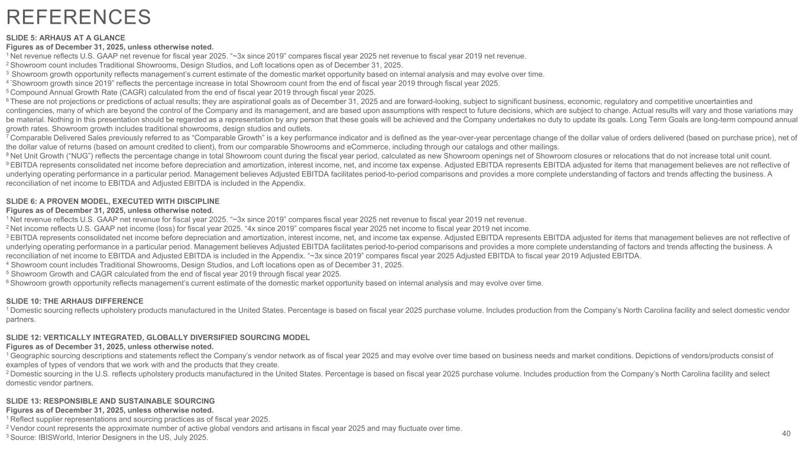
REFERENCES SLIDE 5: ARHAUS AT A GLANCE Figures as of December 31, 2025, unless otherwise noted. 1 Net revenue reflects U.S. GAAP net revenue for fiscal year 2025. “~3x since 2019” compares fiscal year 2025 net revenue to fiscal year 2019 net revenue. 2 Showroom count includes Traditional Showrooms, Design Studios, and Loft locations open as of December 31, 2025. 3 Showroom growth opportunity reflects management’s current estimate of the domestic market opportunity based on internal analysis and may evolve over time. 4 “Showroom growth since 2019” reflects the percentage increase in total Showroom count from the end of fiscal year 2019 through fiscal year 2025. 5 Compound Annual Growth Rate (CAGR) calculated from the end of fiscal year 2019 through fiscal year 2025. 6 These are not projections or predictions of actual results; they are aspirational goals as of December 31, 2025 and are forward-looking, subject to significant business, economic, regulatory and competitive uncertainties and contingencies, many of which are beyond the control of the Company and its management, and are based upon assumptions with respect to future decisions, which are subject to change. Actual results will vary and those variations may be material. Nothing in this presentation should be regarded as a representation by any person that these goals will be achieved and the Company undertakes no duty to update its goals. Long Term Goals are long-term compound annual growth rates. Showroom growth includes traditional showrooms, design studios and outlets. ​ 7 Comparable Delivered Sales previously referred to as “Comparable Growth” is a key performance indicator and is defined as the year-over-year percentage change of the dollar value of orders delivered (based on purchase price), net of the dollar value of returns (based on amount credited to client), from our comparable Showrooms and eCommerce, including through our catalogs and other mailings. 8 Net Unit Growth (“NUG”) reflects the percentage change in total Showroom count during the fiscal year period, calculated as new Showroom openings net of Showroom closures or relocations that do not increase total unit count. 9 EBITDA represents consolidated net income before depreciation and amortization, interest income, net, and income tax expense. Adjusted EBITDA represents EBITDA adjusted for items that management believes are not reflective of underlying operating performance in a particular period. Management believes Adjusted EBITDA facilitates period-to-period comparisons and provides a more complete understanding of factors and trends affecting the business. A reconciliation of net income to EBITDA and Adjusted EBITDA is included in the Appendix. SLIDE 6: A PROVEN MODEL, EXECUTED WITH DISCIPLINE Figures as of December 31, 2025, unless otherwise noted. 1 Net revenue reflects U.S. GAAP net revenue for fiscal year 2025. “~3x since 2019” compares fiscal year 2025 net revenue to fiscal year 2019 net revenue. 2 Net income reflects U.S. GAAP net income (loss) for fiscal year 2025. “4x since 2019” compares fiscal year 2025 net income to fiscal year 2019 net income. 3 EBITDA represents consolidated net income before depreciation and amortization, interest income, net, and income tax expense. Adjusted EBITDA represents EBITDA adjusted for items that management believes are not reflective of underlying operating performance in a particular period. Management believes Adjusted EBITDA facilitates period-to-period comparisons and provides a more complete understanding of factors and trends affecting the business. A reconciliation of net income to EBITDA and Adjusted EBITDA is included in the Appendix. “~3x since 2019” compares fiscal year 2025 Adjusted EBITDA to fiscal year 2019 Adjusted EBITDA. 4 Showroom count includes Traditional Showrooms, Design Studios, and Loft locations open as of December 31, 2025. 5 Showroom Growth and CAGR calculated from the end of fiscal year 2019 through fiscal year 2025. 6 Showroom growth opportunity reflects management’s current estimate of the domestic market opportunity based on internal analysis and may evolve over time. SLIDE 10: THE ARHAUS DIFFERENCE 1 Domestic sourcing reflects upholstery products manufactured in the United States. Percentage is based on fiscal year 2025 purchase volume. Includes production from the Company’s North Carolina facility and select domestic vendor partners. SLIDE 12: VERTICALLY INTEGRATED, GLOBALLY DIVERSIFIED SOURCING MODEL Figures as of December 31, 2025, unless otherwise noted. 1 Geographic sourcing descriptions and statements reflect the Company’s vendor network as of fiscal year 2025 and may evolve over time based on business needs and market conditions. Depictions of vendors/products consist of examples of types of vendors that we work with and the products that they create. 2 Domestic sourcing in the U.S. reflects upholstery products manufactured in the United States. Percentage is based on fiscal year 2025 purchase volume. Includes production from the Company’s North Carolina facility and select domestic vendor partners. SLIDE 13: RESPONSIBLE AND SUSTAINABLE SOURCING Figures as of December 31, 2025, unless otherwise noted. 1 Reflect supplier representations and sourcing practices as of fiscal year 2025. 2 Vendor count represents the approximate number of active global vendors and artisans in fiscal year 2025 and may fluctuate over time. 3 Source: IBISWorld, Interior Designers in the US, July 2025. 40

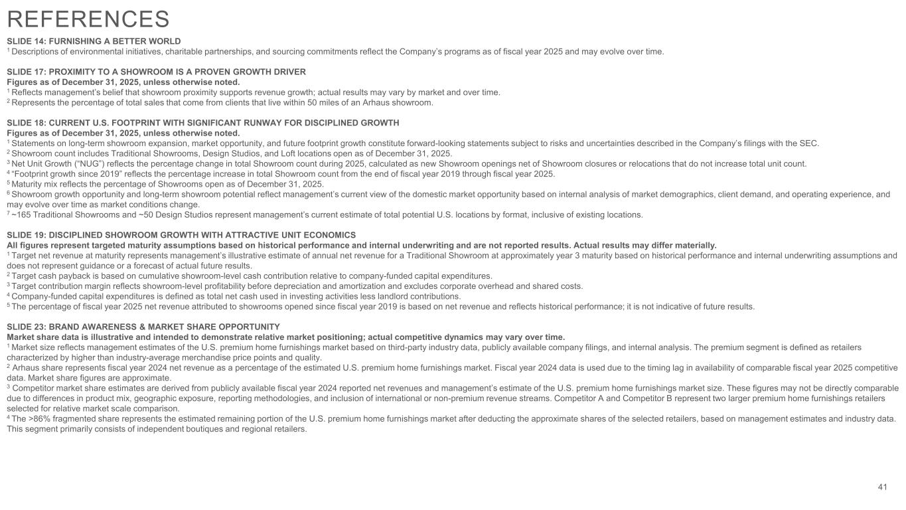
SLIDE 14: FURNISHING A BETTER WORLD 1 Descriptions of environmental initiatives, charitable partnerships, and sourcing commitments reflect the Company’s programs as of fiscal year 2025 and may evolve over time. SLIDE 17: PROXIMITY TO A SHOWROOM IS A PROVEN GROWTH DRIVER Figures as of December 31, 2025, unless otherwise noted. 1 Reflects management’s belief that showroom proximity supports revenue growth; actual results may vary by market and over time. 2 Represents the percentage of total sales that come from clients that live within 50 miles of an Arhaus showroom. SLIDE 18: CURRENT U.S. FOOTPRINT WITH SIGNIFICANT RUNWAY FOR DISCIPLINED GROWTH Figures as of December 31, 2025, unless otherwise noted. 1 Statements on long-term showroom expansion, market opportunity, and future footprint growth constitute forward-looking statements subject to risks and uncertainties described in the Company’s filings with the SEC. 2 Showroom count includes Traditional Showrooms, Design Studios, and Loft locations open as of December 31, 2025. 3 Net Unit Growth (“NUG”) reflects the percentage change in total Showroom count during 2025, calculated as new Showroom openings net of Showroom closures or relocations that do not increase total unit count. 4 “Footprint growth since 2019” reflects the percentage increase in total Showroom count from the end of fiscal year 2019 through fiscal year 2025. 5 Maturity mix reflects the percentage of Showrooms open as of December 31, 2025. 6 Showroom growth opportunity and long-term showroom potential reflect management’s current view of the domestic market opportunity based on internal analysis of market demographics, client demand, and operating experience, and may evolve over time as market conditions change. 7 ~165 Traditional Showrooms and ~50 Design Studios represent management’s current estimate of total potential U.S. locations by format, inclusive of existing locations. SLIDE 19: DISCIPLINED SHOWROOM GROWTH WITH ATTRACTIVE UNIT ECONOMICS All figures represent targeted maturity assumptions based on historical performance and internal underwriting and are not reported results. Actual results may differ materially. 1 Target net revenue at maturity represents management’s illustrative estimate of annual net revenue for a Traditional Showroom at approximately year 3 maturity based on historical performance and internal underwriting assumptions and does not represent guidance or a forecast of actual future results. 2 Target cash payback is based on cumulative showroom-level cash contribution relative to company-funded capital expenditures. 3 Target contribution margin reflects showroom-level profitability before depreciation and amortization and excludes corporate overhead and shared costs. 4 Company-funded capital expenditures is defined as total net cash used in investing activities less landlord contributions. 5 The percentage of fiscal year 2025 net revenue attributed to showrooms opened since fiscal year 2019 is based on net revenue and reflects historical performance; it is not indicative of future results. SLIDE 23: BRAND AWARENESS & MARKET SHARE OPPORTUNITY Market share data is illustrative and intended to demonstrate relative market positioning; actual competitive dynamics may vary over time. 1 Market size reflects management estimates of the U.S. premium home furnishings market based on third-party industry data, publicly available company filings, and internal analysis. The premium segment is defined as retailers characterized by higher than industry-average merchandise price points and quality. 2 Arhaus share represents fiscal year 2024 net revenue as a percentage of the estimated U.S. premium home furnishings market. Fiscal year 2024 data is used due to the timing lag in availability of comparable fiscal year 2025 competitive data. Market share figures are approximate. 3 Competitor market share estimates are derived from publicly available fiscal year 2024 reported net revenues and management’s estimate of the U.S. premium home furnishings market size. These figures may not be directly comparable due to differences in product mix, geographic exposure, reporting methodologies, and inclusion of international or non-premium revenue streams. Competitor A and Competitor B represent two larger premium home furnishings retailers selected for relative market scale comparison. 4 The >86% fragmented share represents the estimated remaining portion of the U.S. premium home furnishings market after deducting the approximate shares of the selected retailers, based on management estimates and industry data. This segment primarily consists of independent boutiques and regional retailers. 41 REFERENCES

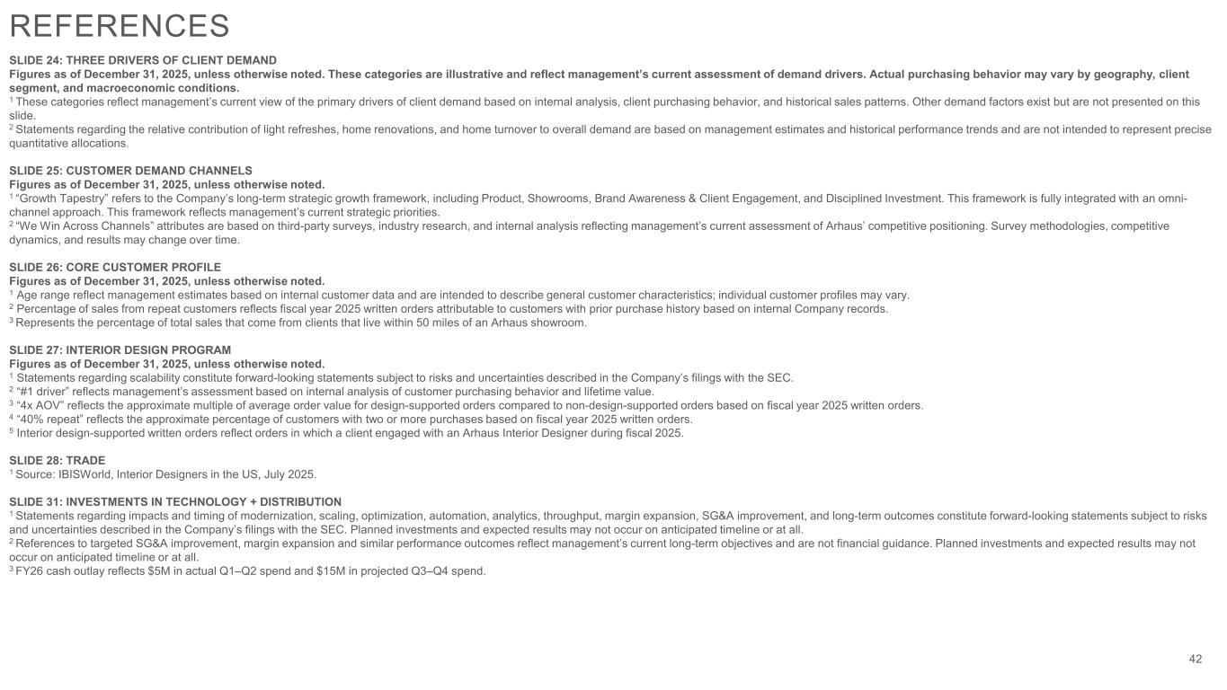
SLIDE 24: THREE DRIVERS OF CLIENT DEMAND Figures as of December 31, 2025, unless otherwise noted. These categories are illustrative and reflect management’s current assessment of demand drivers. Actual purchasing behavior may vary by geography, client segment, and macroeconomic conditions. 1 These categories reflect management’s current view of the primary drivers of client demand based on internal analysis, client purchasing behavior, and historical sales patterns. Other demand factors exist but are not presented on this slide. 2 Statements regarding the relative contribution of light refreshes, home renovations, and home turnover to overall demand are based on management estimates and historical performance trends and are not intended to represent precise quantitative allocations. SLIDE 25: CUSTOMER DEMAND CHANNELS Figures as of December 31, 2025, unless otherwise noted. 1 “Growth Tapestry” refers to the Company’s long-term strategic growth framework, including Product, Showrooms, Brand Awareness & Client Engagement, and Disciplined Investment. This framework is fully integrated with an omni- channel approach. This framework reflects management’s current strategic priorities. 2 “We Win Across Channels” attributes are based on third-party surveys, industry research, and internal analysis reflecting management’s current assessment of Arhaus’ competitive positioning. Survey methodologies, competitive dynamics, and results may change over time. SLIDE 26: CORE CUSTOMER PROFILE Figures as of December 31, 2025, unless otherwise noted. 1 Age range reflect management estimates based on internal customer data and are intended to describe general customer characteristics; individual customer profiles may vary. 2 Percentage of sales from repeat customers reflects fiscal year 2025 written orders attributable to customers with prior purchase history based on internal Company records. 3 Represents the percentage of total sales that come from clients that live within 50 miles of an Arhaus showroom. SLIDE 27: INTERIOR DESIGN PROGRAM Figures as of December 31, 2025, unless otherwise noted. 1 Statements regarding scalability constitute forward-looking statements subject to risks and uncertainties described in the Company’s filings with the SEC. 2 “#1 driver” reflects management’s assessment based on internal analysis of customer purchasing behavior and lifetime value. 3 “4x AOV” reflects the approximate multiple of average order value for design-supported orders compared to non-design-supported orders based on fiscal year 2025 written orders. 4 “40% repeat” reflects the approximate percentage of customers with two or more purchases based on fiscal year 2025 written orders. 5 Interior design-supported written orders reflect orders in which a client engaged with an Arhaus Interior Designer during fiscal 2025. SLIDE 28: TRADE 1 Source: IBISWorld, Interior Designers in the US, July 2025. SLIDE 31: INVESTMENTS IN TECHNOLOGY + DISTRIBUTION 1 Statements regarding impacts and timing of modernization, scaling, optimization, automation, analytics, throughput, margin expansion, SG&A improvement, and long-term outcomes constitute forward-looking statements subject to risks and uncertainties described in the Company’s filings with the SEC. Planned investments and expected results may not occur on anticipated timeline or at all. 2 References to targeted SG&A improvement, margin expansion and similar performance outcomes reflect management’s current long-term objectives and are not financial guidance. Planned investments and expected results may not occur on anticipated timeline or at all. 3 FY26 cash outlay reflects $5M in actual Q1–Q2 spend and $15M in projected Q3–Q4 spend. 42 REFERENCES

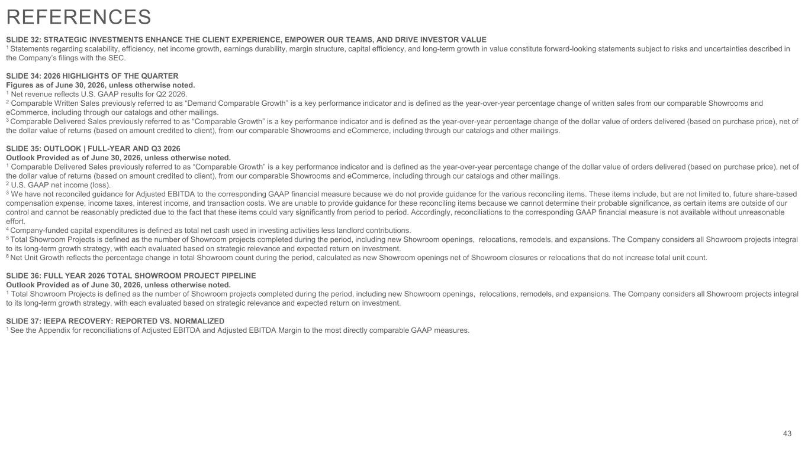
SLIDE 32: STRATEGIC INVESTMENTS ENHANCE THE CLIENT EXPERIENCE, EMPOWER OUR TEAMS, AND DRIVE INVESTOR VALUE 1 Statements regarding scalability, efficiency, net income growth, earnings durability, margin structure, capital efficiency, and long-term growth in value constitute forward-looking statements subject to risks and uncertainties described in the Company’s filings with the SEC. SLIDE 34: 2026 HIGHLIGHTS OF THE QUARTER Figures as of June 30, 2026, unless otherwise noted. 1 Net revenue reflects U.S. GAAP results for Q2 2026. 2 Comparable Written Sales previously referred to as “Demand Comparable Growth” is a key performance indicator and is defined as the year-over-year percentage change of written sales from our comparable Showrooms and eCommerce, including through our catalogs and other mailings. 3 Comparable Delivered Sales previously referred to as “Comparable Growth” is a key performance indicator and is defined as the year-over-year percentage change of the dollar value of orders delivered (based on purchase price), net of the dollar value of returns (based on amount credited to client), from our comparable Showrooms and eCommerce, including through our catalogs and other mailings. SLIDE 35: OUTLOOK | FULL-YEAR AND Q3 2026 Outlook Provided as of June 30, 2026, unless otherwise noted. 1 Comparable Delivered Sales previously referred to as “Comparable Growth” is a key performance indicator and is defined as the year-over-year percentage change of the dollar value of orders delivered (based on purchase price), net of the dollar value of returns (based on amount credited to client), from our comparable Showrooms and eCommerce, including through our catalogs and other mailings. 2 U.S. GAAP net income (loss). 3 We have not reconciled guidance for Adjusted EBITDA to the corresponding GAAP financial measure because we do not provide guidance for the various reconciling items. These items include, but are not limited to, future share-based compensation expense, income taxes, interest income, and transaction costs. We are unable to provide guidance for these reconciling items because we cannot determine their probable significance, as certain items are outside of our control and cannot be reasonably predicted due to the fact that these items could vary significantly from period to period. Accordingly, reconciliations to the corresponding GAAP financial measure is not available without unreasonable effort. 4 Company-funded capital expenditures is defined as total net cash used in investing activities less landlord contributions. 5 Total Showroom Projects is defined as the number of Showroom projects completed during the period, including new Showroom openings, relocations, remodels, and expansions. The Company considers all Showroom projects integral to its long-term growth strategy, with each evaluated based on strategic relevance and expected return on investment. 6 Net Unit Growth reflects the percentage change in total Showroom count during the period, calculated as new Showroom openings net of Showroom closures or relocations that do not increase total unit count. SLIDE 36: FULL YEAR 2026 TOTAL SHOWROOM PROJECT PIPELINE Outlook Provided as of June 30, 2026, unless otherwise noted. 1 Total Showroom Projects is defined as the number of Showroom projects completed during the period, including new Showroom openings, relocations, remodels, and expansions. The Company considers all Showroom projects integral to its long-term growth strategy, with each evaluated based on strategic relevance and expected return on investment. SLIDE 37: IEEPA RECOVERY: REPORTED VS. NORMALIZED 1 See the Appendix for reconciliations of Adjusted EBITDA and Adjusted EBITDA Margin to the most directly comparable GAAP measures. 43 REFERENCES

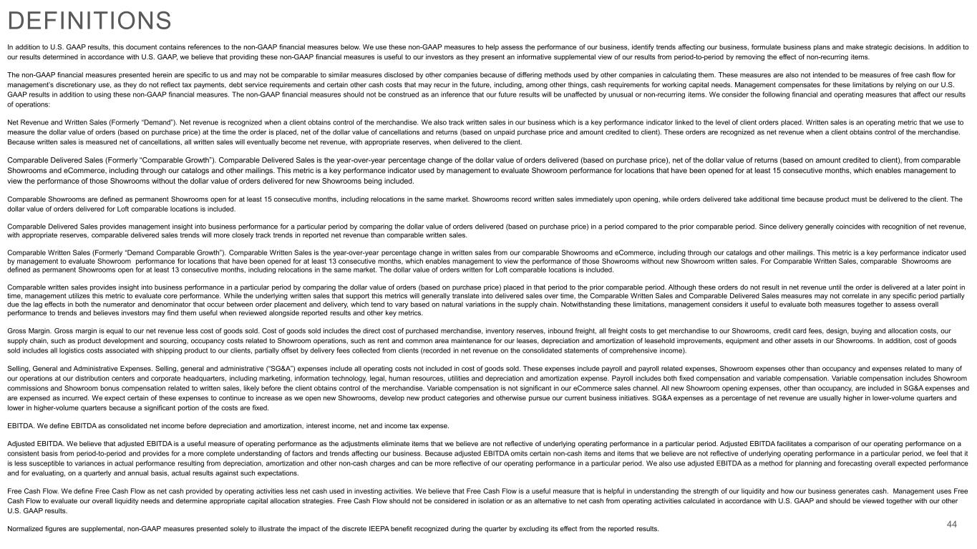
In addition to U.S. GAAP results, this document contains references to the non-GAAP financial measures below. We use these non-GAAP measures to help assess the performance of our business, identify trends affecting our business, formulate business plans and make strategic decisions. In addition to our results determined in accordance with U.S. GAAP, we believe that providing these non-GAAP financial measures is useful to our investors as they present an informative supplemental view of our results from period-to-period by removing the effect of non-recurring items. The non-GAAP financial measures presented herein are specific to us and may not be comparable to similar measures disclosed by other companies because of differing methods used by other companies in calculating them. These measures are also not intended to be measures of free cash flow for management’s discretionary use, as they do not reflect tax payments, debt service requirements and certain other cash costs that may recur in the future, including, among other things, cash requirements for working capital needs. Management compensates for these limitations by relying on our U.S. GAAP results in addition to using these non-GAAP financial measures. The non-GAAP financial measures should not be construed as an inference that our future results will be unaffected by unusual or non-recurring items. We consider the following financial and operating measures that affect our results of operations: Net Revenue and Written Sales (Formerly “Demand”). Net revenue is recognized when a client obtains control of the merchandise. We also track written sales in our business which is a key performance indicator linked to the level of client orders placed. Written sales is an operating metric that we use to measure the dollar value of orders (based on purchase price) at the time the order is placed, net of the dollar value of cancellations and returns (based on unpaid purchase price and amount credited to client). These orders are recognized as net revenue when a client obtains control of the merchandise. Because written sales is measured net of cancellations, all written sales will eventually become net revenue, with appropriate reserves, when delivered to the client. Comparable Delivered Sales (Formerly “Comparable Growth”). Comparable Delivered Sales is the year-over-year percentage change of the dollar value of orders delivered (based on purchase price), net of the dollar value of returns (based on amount credited to client), from comparable Showrooms and eCommerce, including through our catalogs and other mailings. This metric is a key performance indicator used by management to evaluate Showroom performance for locations that have been opened for at least 15 consecutive months, which enables management to view the performance of those Showrooms without the dollar value of orders delivered for new Showrooms being included. Comparable Showrooms are defined as permanent Showrooms open for at least 15 consecutive months, including relocations in the same market. Showrooms record written sales immediately upon opening, while orders delivered take additional time because product must be delivered to the client. The dollar value of orders delivered for Loft comparable locations is included. Comparable Delivered Sales provides management insight into business performance for a particular period by comparing the dollar value of orders delivered (based on purchase price) in a period compared to the prior comparable period. Since delivery generally coincides with recognition of net revenue, with appropriate reserves, comparable delivered sales trends will more closely track trends in reported net revenue than comparable written sales. Comparable Written Sales (Formerly “Demand Comparable Growth”). Comparable Written Sales is the year-over-year percentage change in written sales from our comparable Showrooms and eCommerce, including through our catalogs and other mailings. This metric is a key performance indicator used by management to evaluate Showroom performance for locations that have been opened for at least 13 consecutive months, which enables management to view the performance of those Showrooms without new Showroom written sales. For Comparable Written Sales, comparable Showrooms are defined as permanent Showrooms open for at least 13 consecutive months, including relocations in the same market. The dollar value of orders written for Loft comparable locations is included. Comparable written sales provides insight into business performance in a particular period by comparing the dollar value of orders (based on purchase price) placed in that period to the prior comparable period. Although these orders do not result in net revenue until the order is delivered at a later point in time, management utilizes this metric to evaluate core performance. While the underlying written sales that support this metrics will generally translate into delivered sales over time, the Comparable Written Sales and Comparable Delivered Sales measures may not correlate in any specific period partially due the lag effects in both the numerator and denominator that occur between order placement and delivery, which tend to vary based on natural variations in the supply chain. Notwithstanding these limitations, management considers it useful to evaluate both measures together to assess overall performance to trends and believes investors may find them useful when reviewed alongside reported results and other key metrics. Gross Margin. Gross margin is equal to our net revenue less cost of goods sold. Cost of goods sold includes the direct cost of purchased merchandise, inventory reserves, inbound freight, all freight costs to get merchandise to our Showrooms, credit card fees, design, buying and allocation costs, our supply chain, such as product development and sourcing, occupancy costs related to Showroom operations, such as rent and common area maintenance for our leases, depreciation and amortization of leasehold improvements, equipment and other assets in our Showrooms. In addition, cost of goods sold includes all logistics costs associated with shipping product to our clients, partially offset by delivery fees collected from clients (recorded in net revenue on the consolidated statements of comprehensive income). Selling, General and Administrative Expenses. Selling, general and administrative (“SG&A”) expenses include all operating costs not included in cost of goods sold. These expenses include payroll and payroll related expenses, Showroom expenses other than occupancy and expenses related to many of our operations at our distribution centers and corporate headquarters, including marketing, information technology, legal, human resources, utilities and depreciation and amortization expense. Payroll includes both fixed compensation and variable compensation. Variable compensation includes Showroom commissions and Showroom bonus compensation related to written sales, likely before the client obtains control of the merchandise. Variable compensation is not significant in our eCommerce sales channel. All new Showroom opening expenses, other than occupancy, are included in SG&A expenses and are expensed as incurred. We expect certain of these expenses to continue to increase as we open new Showrooms, develop new product categories and otherwise pursue our current business initiatives. SG&A expenses as a percentage of net revenue are usually higher in lower-volume quarters and lower in higher-volume quarters because a significant portion of the costs are fixed. EBITDA. We define EBITDA as consolidated net income before depreciation and amortization, interest income, net and income tax expense. Adjusted EBITDA. We believe that adjusted EBITDA is a useful measure of operating performance as the adjustments eliminate items that we believe are not reflective of underlying operating performance in a particular period. Adjusted EBITDA facilitates a comparison of our operating performance on a consistent basis from period-to-period and provides for a more complete understanding of factors and trends affecting our business. Because adjusted EBITDA omits certain non-cash items and items that we believe are not reflective of underlying operating performance in a particular period, we feel that it is less susceptible to variances in actual performance resulting from depreciation, amortization and other non-cash charges and can be more reflective of our operating performance in a particular period. We also use adjusted EBITDA as a method for planning and forecasting overall expected performance and for evaluating, on a quarterly and annual basis, actual results against such expectations. Free Cash Flow. We define Free Cash Flow as net cash provided by operating activities less net cash used in investing activities. We believe that Free Cash Flow is a useful measure that is helpful in understanding the strength of our liquidity and how our business generates cash. Management uses Free Cash Flow to evaluate our overall liquidity needs and determine appropriate capital allocation strategies. Free Cash Flow should not be considered in isolation or as an alternative to net cash from operating activities calculated in accordance with U.S. GAAP and should be viewed together with our other U.S. GAAP results. Normalized figures are supplemental, non-GAAP measures presented solely to illustrate the impact of the discrete IEEPA benefit recognized during the quarter by excluding its effect from the reported results. 44 DEFINITIONS

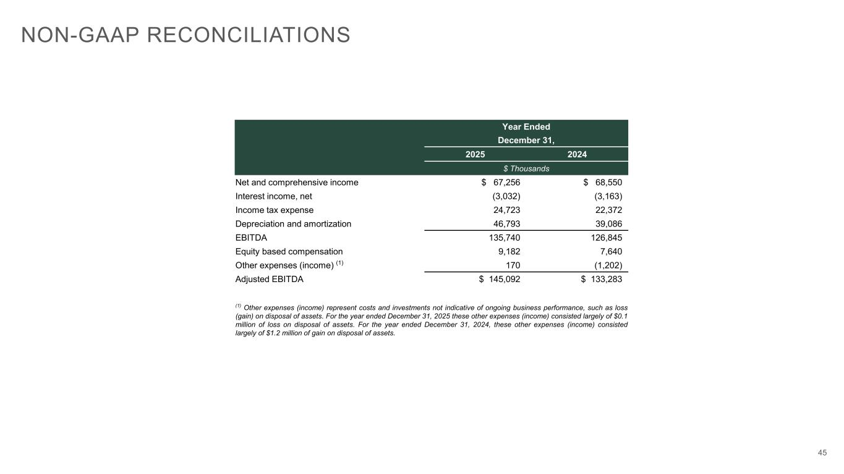
45 Year Ended December 31, 2025 2024 $ Thousands Net and comprehensive income $ 67,256 $ 68,550 Interest income, net (3,032) (3,163) Income tax expense 24,723 22,372 Depreciation and amortization 46,793 39,086 EBITDA 135,740 126,845 Equity based compensation 9,182 7,640 Other expenses (income) (1) 170 (1,202) Adjusted EBITDA $ 145,092 $ 133,283 (1) Other expenses (income) represent costs and investments not indicative of ongoing business performance, such as loss (gain) on disposal of assets. For the year ended December 31, 2025 these other expenses (income) consisted largely of $0.1 million of loss on disposal of assets. For the year ended December 31, 2024, these other expenses (income) consisted largely of $1.2 million of gain on disposal of assets. NON-GAAP RECONCILIATIONS

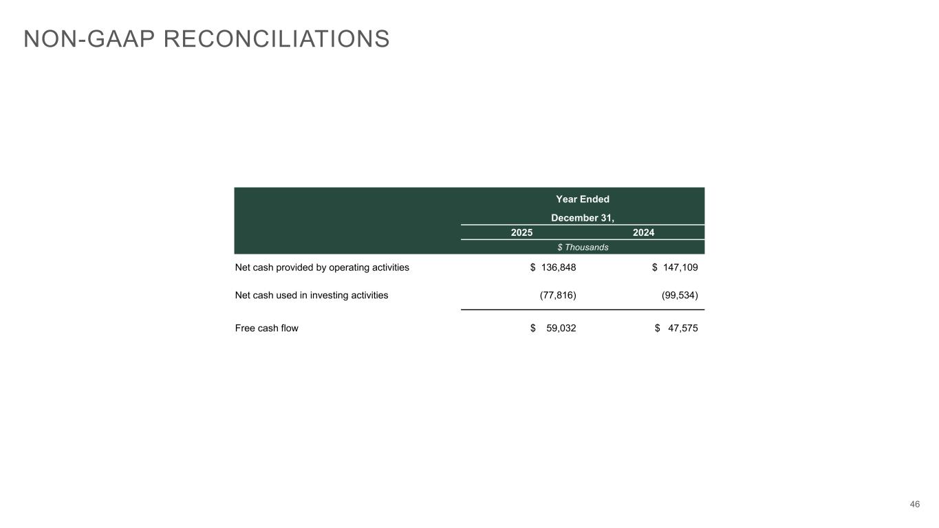
46 Year Ended December 31, 2025 2024 $ Thousands Net cash provided by operating activities $ 136,848 $ 147,109 Net cash used in investing activities (77,816) (99,534) Free cash flow $ 59,032 $ 47,575 NON-GAAP RECONCILIATIONS

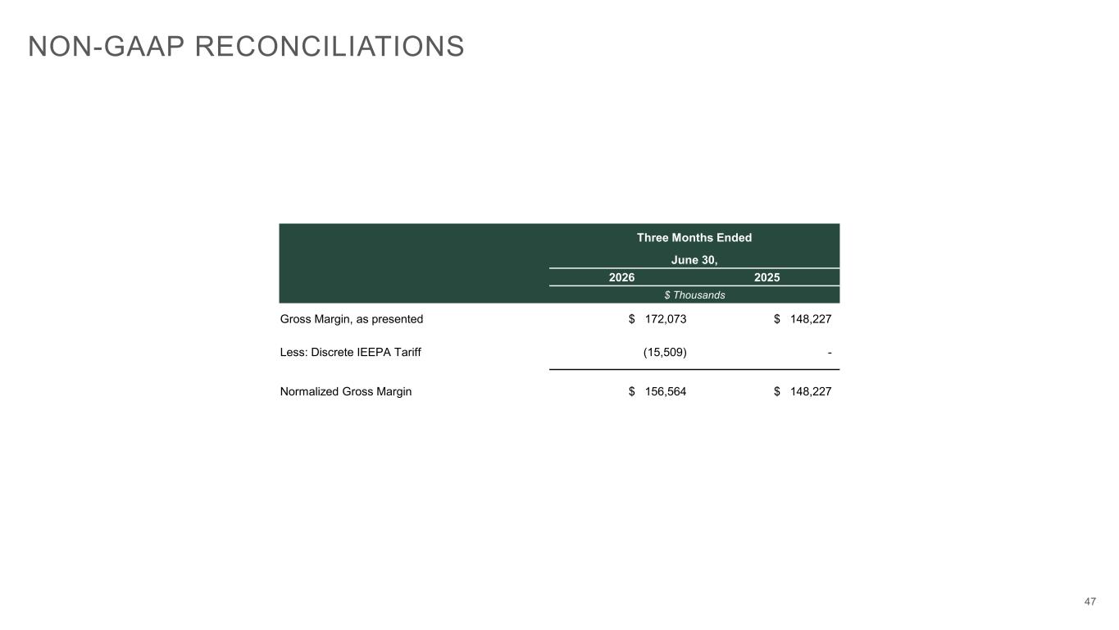
47 Three Months Ended June 30, 2026 2025 $ Thousands Gross Margin, as presented $ 172,073 $ 148,227 Less: Discrete IEEPA Tariff (15,509) - Normalized Gross Margin $ 156,564 $ 148,227 NON-GAAP RECONCILIATIONS

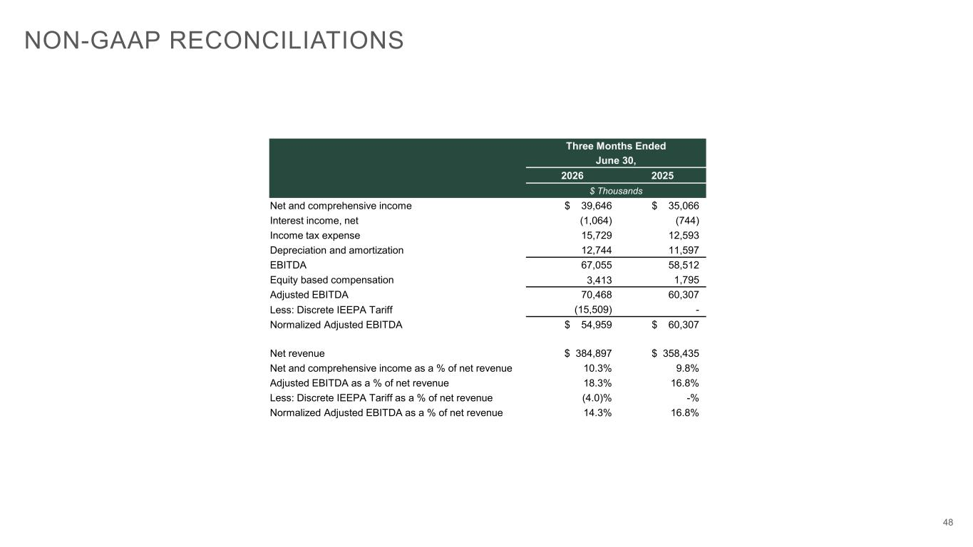
48 NON-GAAP RECONCILIATIONS Three Months Ended June 30, 2026 2025 $ Thousands Net and comprehensive income $ 39,646 $ 35,066 Interest income, net (1,064) (744) Income tax expense 15,729 12,593 Depreciation and amortization 12,744 11,597 EBITDA 67,055 58,512 Equity based compensation 3,413 1,795 Adjusted EBITDA 70,468 60,307 Less: Discrete IEEPA Tariff (15,509) - Normalized Adjusted EBITDA $ 54,959 $ 60,307 Net revenue $ 384,897 $ 358,435 Net and comprehensive income as a % of net revenue 10.3% 9.8% Adjusted EBITDA as a % of net revenue 18.3% 16.8% Less: Discrete IEEPA Tariff as a % of net revenue (4.0)% -% Normalized Adjusted EBITDA as a % of net revenue 14.3% 16.8%


49

